YEAR 4 PAST SIMPLE PRACTICE
1a.Make negative sentences.
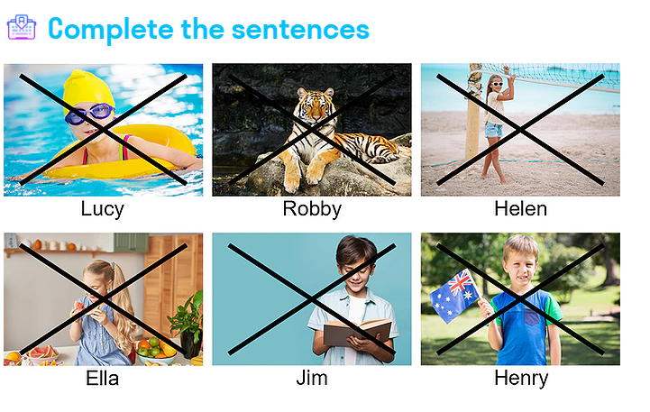
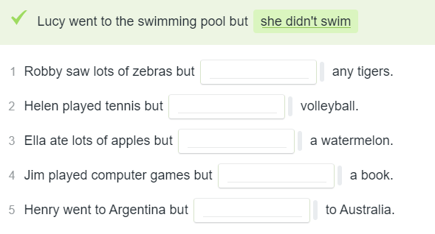
1b
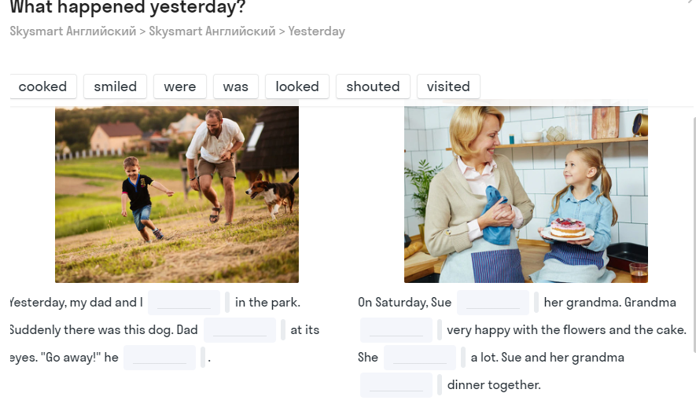
1c.Write 5 sentences about things that did you last week and 5 sentences about things that you didn’t do last wek.
_________________________________________________________________________________________________________________________________________________________________________________________________________________________________________________________________________________________________________________________________________________________________________________________________________________________________________________________________________________________________________________________________________________________________________________________________________________________________________________________________________________________________________________________________________________________________________________________________________________________________________________________
___________________________________________________________________________
_________________________________________________________________

2a READ AND COMPLETE THE STORY WITH THE WORDS IN PAST SIMPLE
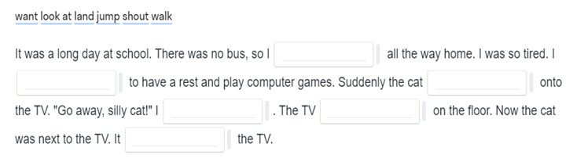
2b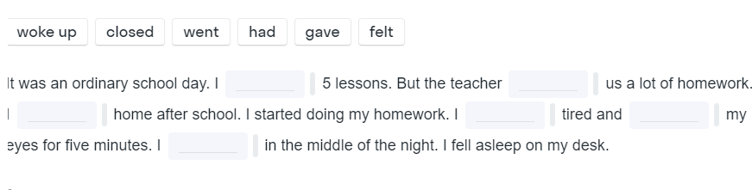Wake-woke-проснуться Fall-fell asleep—заснуть middle-середина
2c Answer the questions:
1.What day of the week was it yesterday? 2. What time did you wake up yesterday? 3. Did you have any breakfast? 4. When did you start doing your school lessons yesterday? 5. How many lessons did you have? 6. Were you tired? 7. What time did you have lunch? 8. What did you have for lunch? 9. What did you do in the afternoon? 10. What time did you fall asleep?
______________________________________________________________________________________________________________________________________________________________________________________________________________________________________________________________________________________________________________________________________________________________________________________________________
__________________________________________________________________________________________________________________________________
3a. READ AND COMPLETE THE STORY WITH THE WORDS IN PAST SIMPLE
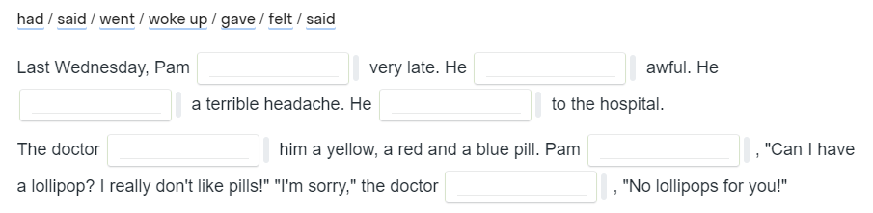
3b
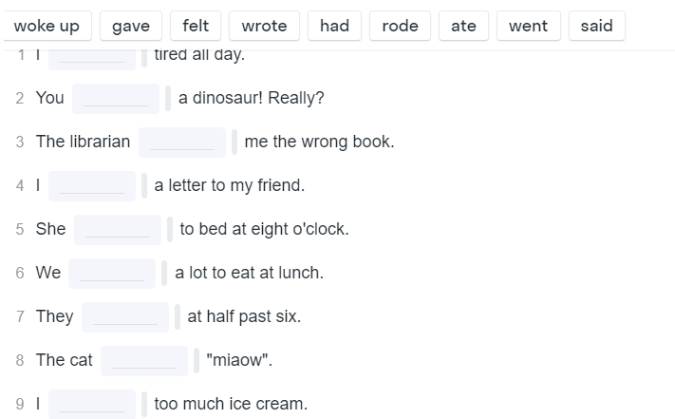
3 c. Put sentences in the correct order.
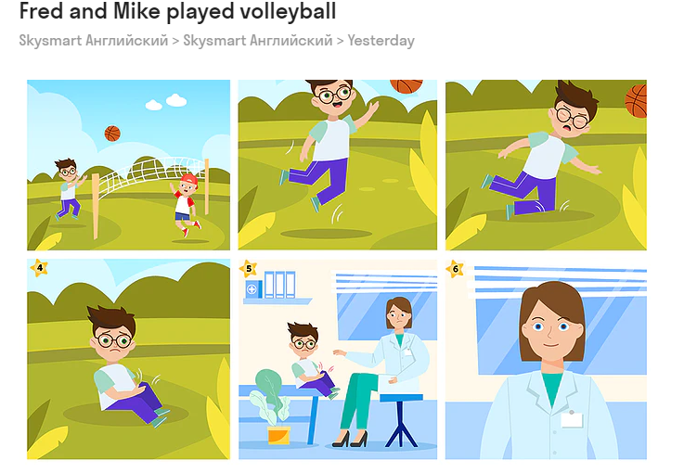
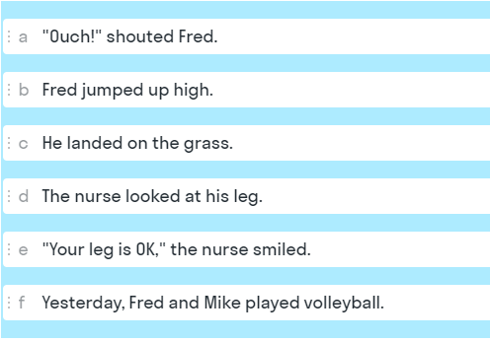

2e

