Бекітемін __________
Unit of a long term plan |  |  | School: №36 secondary school
Date: 8A 11.12.17  8B 11.12.17  8V 12.12.17 |  |  | Teacher name: Orazova A.
Grade 8th |  |  | Number present: | absent:
Lesson title |  | A day at school
Learning objectives(s) that this lesson is contributing to (link to the Subject programme) |  | S1. Provide basic information about themselves and others at sentence level on an increasing range of general topics.  S4. Respond with limited flexibility at sentence level to unexpected comments on an increasing range of general and curricular topics.  W1. Plan, write, edit and proofread work at text level with support on a limited range of general and curricular topics.
Assessment criteria |  | To ask simple questions to get information about schools  To develop the learners’ correct pronunciation of active vocabulary  To write and complete the sentences about education.
Values links |  | To respect each others opinion, to awake of their patriotic senses. To teach pupil to love our history  Learning to speak about the Secondary education. To develop students’ critical thinking, their abilities to work in groups, self assessment.
Plan
Planned timings | Planned activities (replace the notes below with your planned activities) |  |  | Resources
Start | 1. Organization moment: greeting the students.  2.Dividing the class into groups.  3. Checking up homework:  1.Good morning! How are you?  2. Divides students.  3. Active vocabulary by chain.  -Morning! We are fine!  a) Greeting  b) The report of the pupil on duty  c) Introduce the theme:
Middle | Task1.Read the text «A day at my school»  1.Boys and girls come to school nearly 9 after Saturday and Sunday?  2. Some of the children come on their cars.  3. At 11 boys and girls go out into the dining room to collect their milk.  4. In England every boy and girl at school is given milk every day.  5. They have lunch at 12 o'clock.  6. All school children in England have their lunch at home.  7. At 3 o'clock lessons start again.  8. The children do lessons like history, geography and maths in the afternoon.  9. The girls learn to type and sew and cook in the afternoon.  10. The boys do metalwork and woodwork in the afternoon.  11. Lessons are over at 5 o'clock.  12. The children collect their books and hurry to go home.  Task2. Brainstorming.  - Ok. Look at the active board. You’ll see a rhyme. Listen to me careful and then repeat after me.  The more we learn, the more we forget,  The more we forget, the less we know,  The less we know, the less we forget,  Why study?  We study at school because …  We go to school because …  Grammar: Modal verbs Must/ have to  Must= to express obligation = I must go now  Must= to express strong belief= she must be over 90 years old  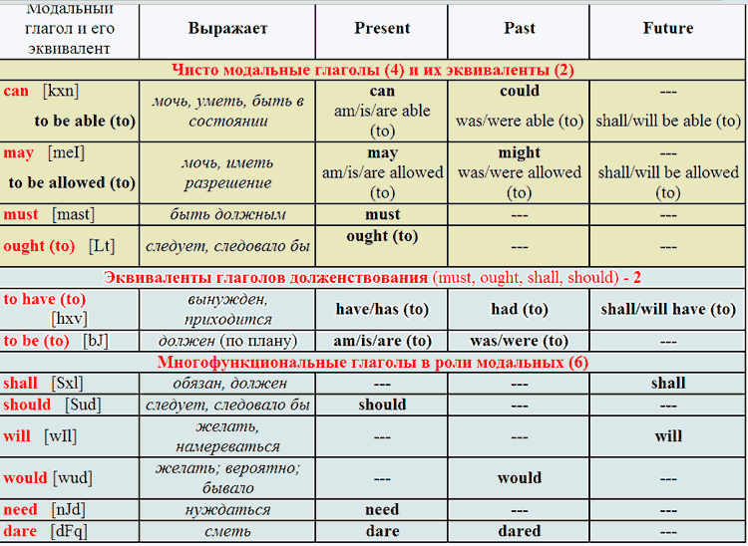  Task4. Speaking.  - Now, answer the question using these words:  To want to know everything;  To like learning process;  To get good marks;  To one’s success delight parents;  The lesson interesting;  To bring joy to one’s parents;  To want to learn how to solve problems;  To be useful to people;  The teacher was pleased with one’s progress;  To me for one’s successes respected friends;  Consolidation of the new material Pupils will listen the one girl’s speaking about a day at her school. Then will retell what they heard and understand. 10 min  Conclusion What have we learned today? Students have an ability to speak about their daily life at school. They have learned a wide range of vocabulary regarding the topic. 2 min  Evaluation I’m very glad for your work today. All of you have participated very active. I hope you will be active later too. Your marks are…  5 – Excellent, 4 – Good, 3 – Satisfactory, 2 - Unsatisfactory 1-2 min  Giving home task T: Your home task for the next lesson will beto write a short essay about a day at your school. Also, learn by heart new words.The lesson is over. Thank you and see you next lesson!
End | Homework. Marking. Ex.3 p.87. learn new information about a day at an English school.  T: I’ll give your marks: excellent…good… sad…  T: Everybody, stand up! The lesson is over. Good – bye, pupils.

