Lesson plan
Grade: 3
Theme: Bouncing bubbles
Objectives: 1. to make a chemical reaction
2. to learn new terminology
Resources: WB, cards, water, washing up liquid, glycerin, straw, glass, gloves.
Organization moment
-Good morning children!
-How are you?
-I’m glad to see you.
Realization of meaning
Look! What can you see? (Children will be able to look on a whiteboard and discuss)
We can see bubbles.
Listen and repeat
Bouncing -
Washing up liquid -
Glycerin-
Straw –
Glove -
Thick -
To take -
To mix –
To hold -
Stick word box to your copybook.
MAKING а BOUNCING BUBBLE
- Take water
- Add glycerin
- Add washing up liquid
- Take the straw
- Mix it
- Put on your gloves
- Take the bouncing bubble
Let’s make bubbles! Please first couple…. (They will be able to make bubbles)
Now, what can you say?
What do we have?
What is it?
Reflection
Glycerin makes bubble thick.

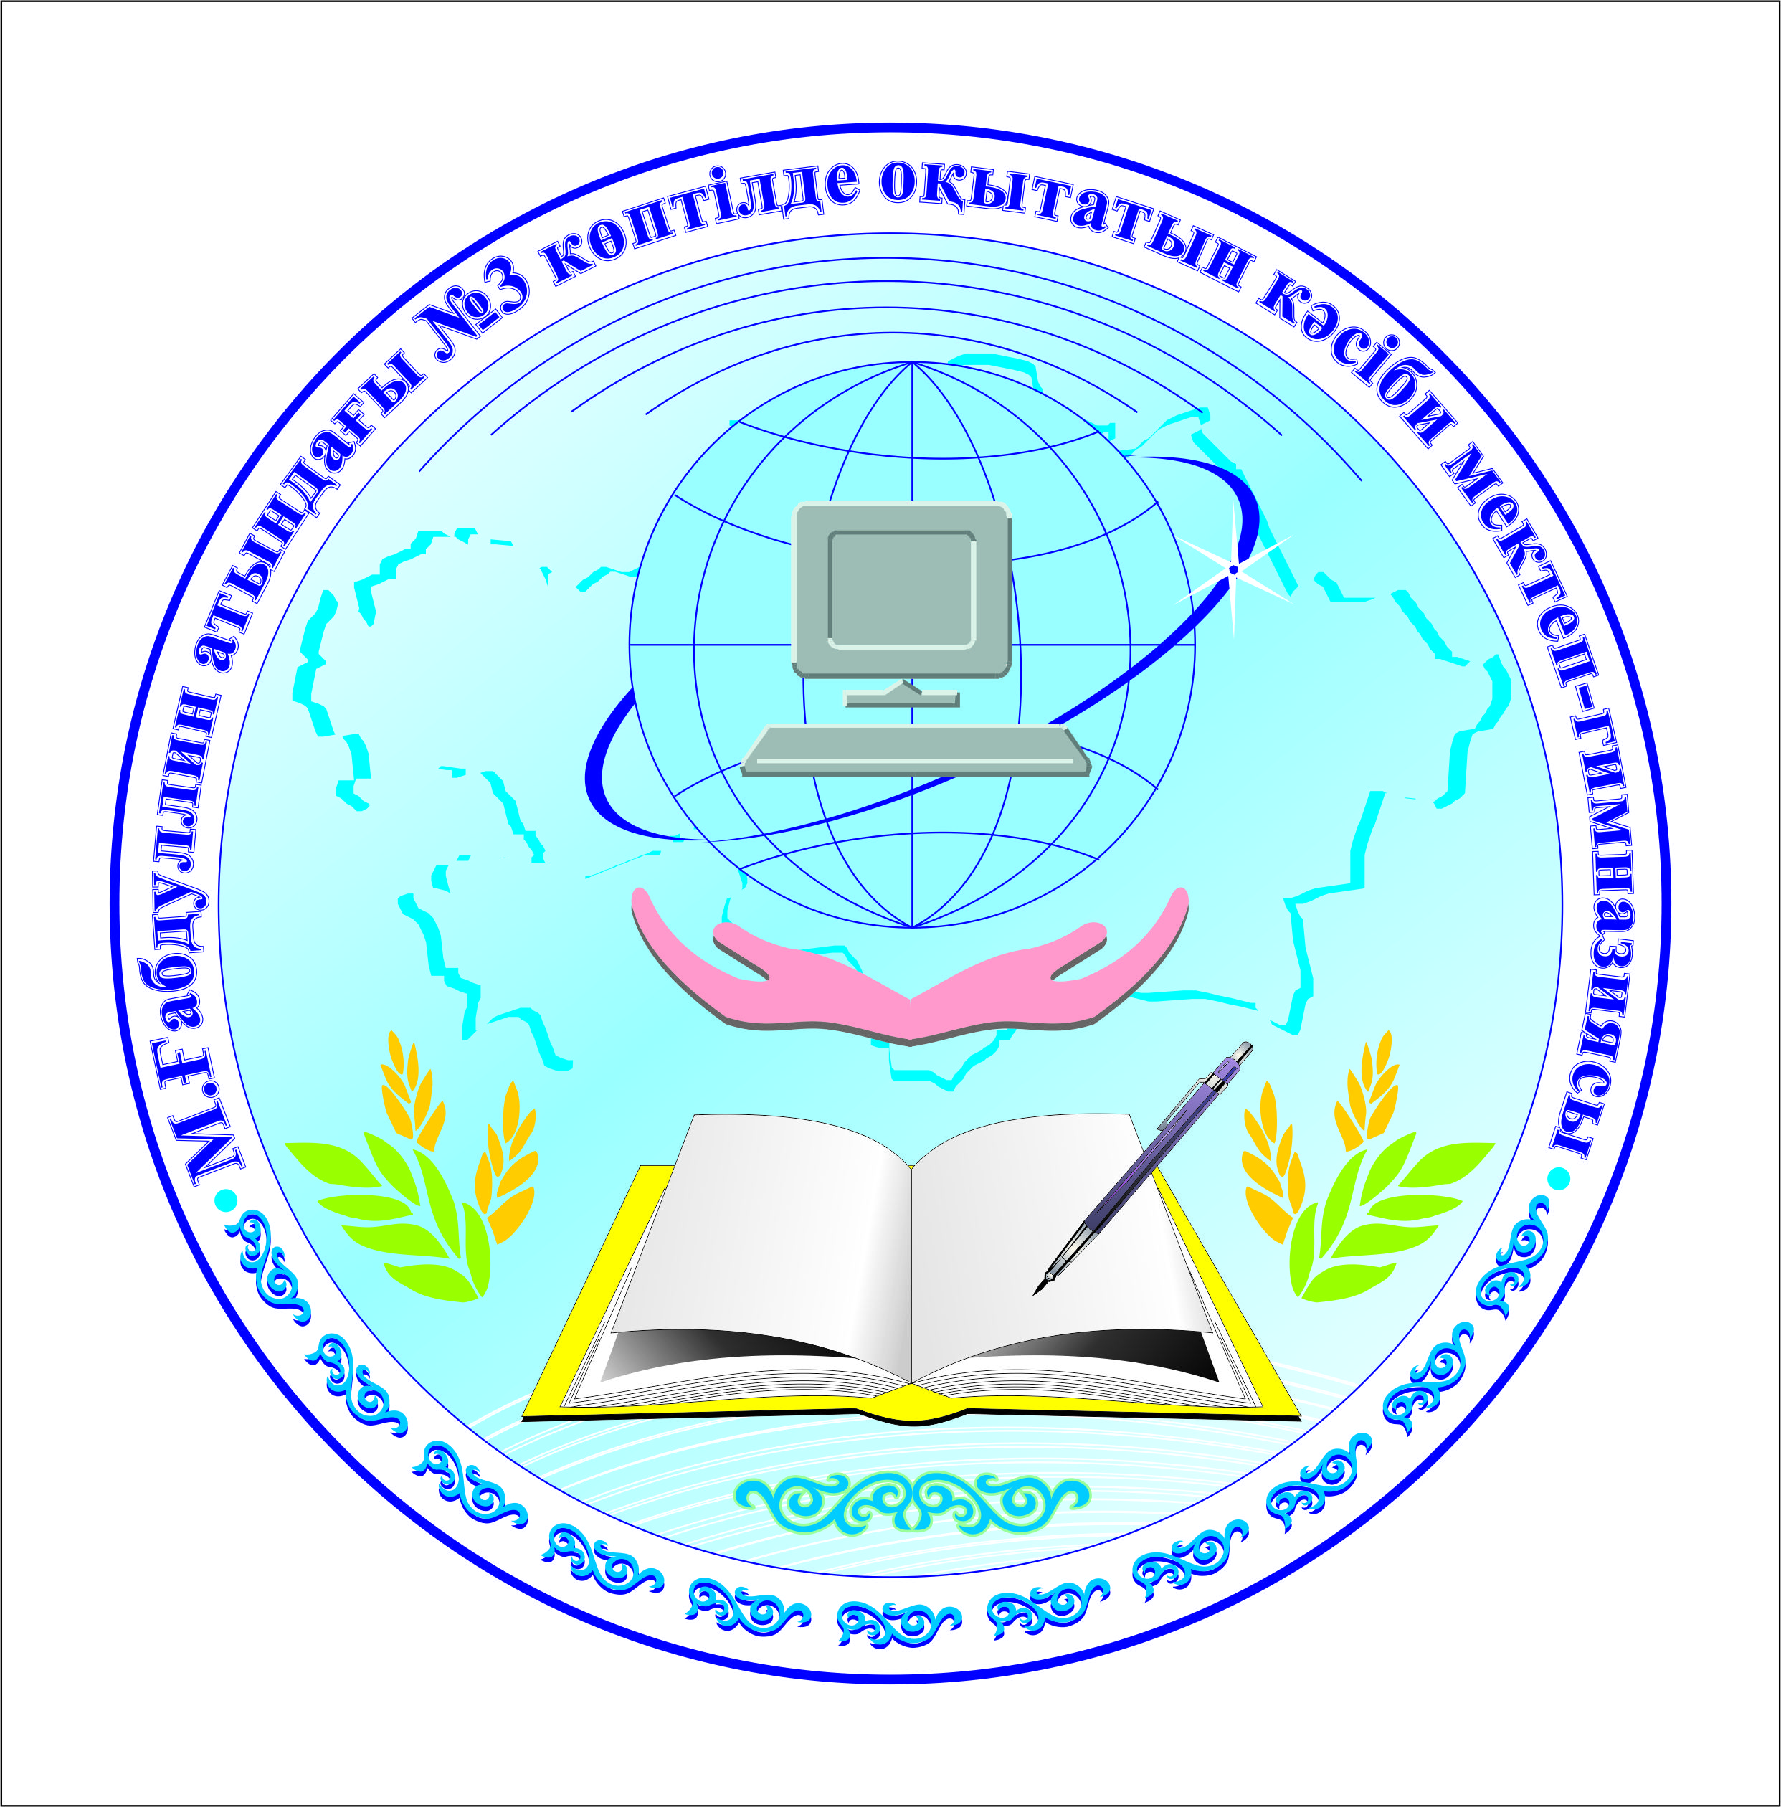

Ашық сабақ
«Bouncing bubbles»

Өткізген:

2015-2016 оқу жылы

