МАКЕТ ВНЕКЛАССНОГО МЕРОПРИЯТИЯ
Брейн-ринг: «Знатоки Английского»
Тема Брейн-Ринга: Англо-говорящие страны
Цель мероприятия: расширить знания детей о культуре, традициях и интересных исторических фактах англо-говорящих стран: Великобрита-
нии, США, Канады, Австралии и Новой Зеландии, тренировать учащихся в
использовании английского языка в устной речи.

Деловая активность учащихся | Виды деятельности
1. Представление команд.  2. Вопросы о Великобритании, США, Ка-наде, Австралии, Новой Зеландии; о лите-ратуре этих стран и общие вопросы.  3. Задания по пословицам и идиомам.  4. «Кто исполнитель этого музыкального произведения?»  5. Конкурс капитанов: отгадать, кто ав-тор этого литературного произведения.  6. Автор произведения.  7. Достопримечательности стран.  8. Фильм.  9. Пословицы и идиомы.  10.Конкурс для болельщиков: загадки.  11. «Угадай слово».  12. «Кто автор?»  13. «Дай полное имя».  14. «Раскодируй слово».  15. Географический конкурс.  16. «Кто на портрете?» | - презентация команд и их лидеров;  - ответы на вопросы об англо-говорящихстра-нах, их культуре, традициях, истории и геогра-фии;  - закончить начатую пословицу;  - правильно перевести пословицу на русский язык;  - прослушивание песен на английском языке, правильно указать на таблицах названия пе-сен и исполнителей;  - под именем писателя разместить названия его литературных произведений;  - прослушивание отрывков литературных про-изведений, и угадывание, что это за произве-дение и кто его автор;  - определить по картинкам достопримечатель-ности англо-говорящих стран и на картинке разместить флаг этой страны;  - после короткого просмотра отрывка из изве-стного фильма нужно определить, какой это фильм.  - закончить начатые пословицы и идиомы;  - правильно перевести пословицы и идиомы на русский язык;  - отгадать загадки;  - дается описание предмета, нужно его угадать  - по прочитанным названиям литературных произведений угадать автора;  - по сокращенным английским и американс-ким именам дать полное имя;  - по заданным цифрам с использованием алфа-вита раскодировать зашифрованное слово;  - найти на контурных картах Великобритании и США заданные места;  - по портрету угадать писателей англо-говоря-щих стран;

BRAN - RING
«TheSmartest»

ANSWER THE QUESTIONS ABOUT GREAT BRITAIN
(1 team)
- What part of Great Britain Glasgow situated in? (in Scotland)
- Which Englishman founded a city in Ukraine? (John Huse - Donetsk)
- A great invention in medicine was made in 1929 by an English microbiologist Flaming. What was it? (Penicillin)
- How many people perished in the Great Fire of London in 1666? (no one)
- What is the famous airport in London? (Heathrow)
- When do English people celebrate Halloween? (on the 31st of October)
- What river is the deepest of all British rivers? (the Thames)
- What country presents a Christmas tree to Great Britain? (Norway)
- How are the words “the English Channel” translated? (Ла-Манш)
- What does abbreviation MP stand for? (Member of Parliament)
- At the beginning of the 19th century the special rules for gentlemen in Great Britain were worked out. According to them the real gentleman had to change smth. 6 times a day. What was it? (gloves)
- The surname often shows what country the man comes from. What is the origin of the people whose family names begin with “Mc”? (Scottish people)
- What is the popular nickname of the London policeman? (Bobby)
- What number is never seen on the buses and cars on the British streets? (666)
- How many vowels are there in the English alphabet? (6)
- What is the traditional costume of a Scotsman? (a kilt)
- What is the name of a flag of the UK? (The Union Jack)
- The British say “As stubborn as a … ”. (mule)
- What is the main square in London? (Trafalgar Square)
- What country is Cardiff the capital of? (Wales)
- What colours are the British post-boxes and telephone boxes? (red)
- Who became the popular character of British legends as a national hero and the protector of the poor? (Robin Hood)
- Which monument is in the centre of Trafalgar Square? (the monument to Nelson)
- What part of London is the symbol of wealth and culture? (the West End)
- What is the symbol of Great Britain? (Big Ben)
ANSWER THE QUESTIONS ABOUT
THE UNITED STATES OF AMERICA (1 team)
- What is the largest state of the USA? (Alaska)
- What is the name of a cartoonist who achieved success with his work “Mickey Mouse”? (Walt Disney)
- Which of the Hollywood actresses starred in “Cleopatra”? (Elizabeth Taylor)
- How many stars and stripes has the US flag? (50 stars and 13 stripes)
- What sights can be seen both, in Canada and the USA? (the Niagara Falls)
- How do they call the American flag? (Stars and Stripes)
- What ocean doesn’t wash the USA? (the Indian Ocean)
- Which state joined the USA last? (Hawaii)
- When is the Independence Day in the USA? (on the 4th of July)
- What do the British and American say when they take a photo? (cheese)
- Who is the main actor of the film “Pirates of the Caribbean”? (Johnny Depp)
- What river does Washington stand on? (on the Potomac River)
- Who was the first president of the USA? (George Washington)
- What was the first name of New York? (New Amsterdam)
- Which is the most popular sport in the USA? (baseball)
- What is the American folk tale which reminds “Kolobok”? (“The Gingerbread boy”)
- Who was the “King” of rock’n’roll? (Elvis Presley)
- How many presidents were there in the USA before Alabama? (43)
19.What is the official language in the USA?(there is no official language in the USA)
20. What do the stars and stripes on the flag of the USA represent? (50 stars
represent states nowadays and 13 stripes represent 13 original states)
21. What is the national flower of the USA? (rose)
22. What do Americans celebrate on the 2nd of February? ( the Groundhog Day)
23. At what age can young people buy alcohol? (at 21)
24. What changed in the life of the American Indians in 1924? (they became the citizens of the USA)
25. Why did 548.000 people die the USA in 1918? (because of the flu epidemic)

ANSWER THE QUESTIONS ABOUT GREAT BRITAIN
(2 team)
- What is the capital of Scotland? (Edinburgh)
- What is the English word for Scottish “loch”? (a lake)
- What English scientist wrote “The Theory of Evolution”? (Charles Darwin)
- Who was called “An iron Lady”? (Margaret Thatcher)
- What London library is the biggest one? (The British Museum Library)
- Where were “The Beatles” born? (in Liverpool)
- Englishmen prefer tea with milk. What tea do they call “Russian”? (Tea with lemon)
- On what day sweethearts say beautiful and pleasant words to each other? (on St. Valentine’s Day)
- Where is the biggest Christmas tree situated in London every year? (Trafalgar Square)
- What is Great Britain washed by in the West? (by the Atlantic Ocean and the Irish Sea)
- What is the longest river in the UK? (the Severn)
- The British often say they have no climate but only …? (weather)
- Sherlock Holmes said that he could define the foreigner only by the turn of his head. When? (When they cross the street)
- How many letters are there in the English alphabet? (26)
- What is the Russian “Indian Summer”? («Бабье лето»)
- The British say “As busy as a …”. (bee)
- What channel separates England from the continent? (English Channel)
- What bird is the national symbol of Britain? (a robin)
- What is the national musical instrument of Northern Ireland? (a harp)
- What is the most famous lake in Scotland? And what is it famous for?(Lock Ness, they say that Loch Ness monster lives in it)
- What is the dialect of English spoken in the East End of London? (Cockney)
- What Houses does the English Parliament consist of? (The House of Lords and the House of Commons)
- What is the capital of Scotland? (Edinburgh)
- What is the capital of Northern Ireland? (Belfast)
- What is the origin of the names which begin with O’? (the Irish origin)

ANSWER THE QUESTIONS ABOUT
THE UNITED STATES OF AMERICA (2 team)
- Who starred in Hollywood film “Pretty Woman”? (Julia Roberts)
- Who presented the statue of Liberty to the people of the USA?(the people of France)
- What is the longest river in the USA? (the Missouri)
- What is Moscow in the USA? (a town)
- What is a soccer? (a football in the USA)
- Where can you see the famous slogan “In God we trust…”? (on the US dollars)
- In what state is the Hollywood situated? (in California)
- Which holiday is called “the birthday of a nation” in the USA? (the Independence Day)
- Who of the presidents fought for the abolition of slavery in the USA? (Lincoln)
- What river does New York stand on? (the Hudson river)
- Which holiday is celebrated on the fourth Thursday of November in the USA? (Thanksgiving Day)
- Which street in New York is called the home of theatres? (Broadway)
- What bird is the national symbol of the USA? (the eagle)
- When did Christopher Columbus discover America? (in 1492)
- How many states are there in the USA? (50)
- What former movie actor became the president of the USA? (Ronald Reagan)
- Who was known as the “King of Jazz”? (Louis Armstrong)
- What game is played with a bat and a small white ball? (baseball)
- What did the Wright brothers invent? (the first airplane)
- Who was the founder of the Microsoft Corporation? (Bill Gates)
- What is the number of an emergency telephone call in the USA? (911)
- How many cents are there in one dollar? (100 cents)
- What was George Washington deadly afraid of? (Of being buried alive)
- What age can you drive a car in the USA at? (at 16)
- What was the first capital in the USA? (New York)

ANSWER THE QUESTIONS ABOUT (1 team)
THE ENGLISHSPEAKING COUNTRIES
- What is the capital of Australia? (Canberra)
- Who discovered New Zealand? (James Cook)
- What reptiles don’t live in New Zealand? (snakes)
- What is the symbol of Canada? (Maple Leaf)
- What century did Europeans settle Australia in? (in the 18th century)
- What is Canada’s national sport? (Hockey)

ANSWER THE LITERATURE QUESTIONS
- What title did G. Byron have? (Lord)
- When was W. Shakespeare born? (in 1564)
- What famous writer had the same name as the capital of a country? (J. London)
- What was the real name of Mark Twain? (Samuel Clemens)
- Why did Kipling hate the war? (He lost his son in the war)
- How many children did W. Shakespeare have? (3)
- One of his poems was devoted to Ukrainian hetman Mazepa (R. Byron)
- He fought for liberation of Italy and Greece. (R. Byron)
- What English author is known as the Queen of Crime? (Agatha Christie)

COMMON QUESTIONS
- Where were the first OlympicGames organized? (in Greece)
- Who invented the radio? (Alexander Popov)
- How is the frozen water called? (ice)
- What is the Newton’s greatest discovery? (The law of the gravitation)
- What is the Olympic emblem? (5 interlinked rings)
- What letter of the English alphabet can see? (I)
- What is the longest river in the world? (the Amazon river)
- What apples do not grow in trees? (Pine apples)
- What did Samuel Morse invent? (the telegraph)
- What are the colours of a rainbow? (red, orange, yellow, green, blue, violet)

ANSWER THE QUESTIONS ABOUT (2 team)
THE ENGLISHSPEAKING COUNTRIES
- Who is the head of the country in Australia? (The Queen of GB)
- What is the capital of New Zealand? (Wellington)
- What is the capital of Canada? (Ottawa)
- What country occupies the whole continent? (Australia)
- What are the two official languages in Canada? (English and French)
- Who is the head of the country in Canada? (The Queen of Britain)

ANSWER THE LITERATURE QUESTIONS
- What was the name of W. Shakespeare theatre? (The Globe)
- Who is the author of “Auld Lang Syne”? (Robert Burns)
- Who wrote the book “Three men in a boat”? (Jerome K. Jerome)
- What are the names of the six serving men of the Kipling’s poem? (Who, When, How, Where, Why, What)
- What was the native town of Romeo and Juliet? (Verona)
- Who is the author of “The Treasure Island”? (R.L. Stevenson)
- He fell ill in his childhood and couldn’t walk. (A. Marshall)
- He is a great American writer. His real name was William Sidney Porter. (O’Henry)
- Who wrote the “Gulliver’s Travels”? (Swift)

COMMON QUESTIONS
- How do they call singing of one person? (solo)
- Who built the first car? (Henry Ford)
- What is the largest ocean? (The Pacific Ocean)
- Where did an orange, a lemon and a peach come from? (from China)
- The name of which animal means “I do not understand you”? (Kangaroo)
- What is in the middle of sea? (letter “e”)
- What animals live the longest life? (tortoise)
- What are the children from 13 to 19 called? (teenagers)
- Who was the first person to walk on the moon? (Neil Armstrong)
- What did Alexander Bell invent? (the telephone)

FINISH THE PROVERBS AND IDIOMS (1)
- All cats are … (grey in the night). – Все коты серые ночью.
- Hungry as a … (hunter).– Голодный как волк.
- Much ado … (about nothing). – Много шума из ничего.
- One man … (no man). – Один в поле не воин.
- To make both ends … (meet). – Еле сводить концы с концами.
- There is no smoke … (without fire). – Нет дыма без огня.
- The devil is not so black … (as he is painted). – Не так страшен черт, как его малюют.
- Don’t trouble trouble until … (trouble troubles you). – Не буди лиха, пока оно спит.
- Never put off till tomorrow what … (you can do today). – Не откладывай на завтра то, что ты можешь сделать сегодня.
- No news is … (good news). – Отсутствие новостей – хорошая новость.

TRANSLATE THE PROVERBS AND IDIOMS
- A bird in the hand is worth two in the bush. – Лучше синица в руке, чем журавль в небе.
- A good beginning is half the battle. – Лиха беда начало.
- A great ship asks deep water. – Большому кораблю – большое плавание.
- An hour in the morning is worth two in the evening. – Утро вечера мудренее.
- As the tree, so the fruit. – Яблочко от яблоньки недалеко катится.
- Вetter a glorious death than a shameful life. – Лучше славная смерть, чем постыдная жизнь.
- The leopard can’t change his sports. – Горбатого могила исправит.
- To come out dry. – Выйти сухим из воды.
- Poverty is no sin. – Бедность не порок.
- Silent as a grave. – Нем как рыба.

FINISH THE PROVERBS AND IDIOMS (2)

- Two heads are better … (than one). – Одна голова хорошо, а две – лучше.
- All is well that … (ends well). – Все хорошо, что хорошо кончается.
- East or West … (home is best). – В гостях хорошо, а дома лучше.
- There is no place … (like home). – В гостях хорошо, а дома лучше.
- A friend in need … (is a friend indeed). – Друзья познаются в беде.
- Better late … (than never). – Лучше поздно, чем никогда.
- Never put off till tomorrow … (what you can do today). – Никогда не откладывай на завтра то, что ты можешь сделать сегодня.
- Better an egg today … (than a hen tomorrow). – Лучше синица в руке, чем журавль в небе.
- A good beginning makes … (a good ending). – Лиха беда начало.
- An apple a day keeps … (the doctor away). – Кушай по яблоку в день и врач тебе не понадобится.

TRANSLATE THE PROVERBSAND IDIOMS
- Better die standing than live kneeling. – Лучше умереть стоя, чем жить на коленях.
- Since Adam was a boy. – При царе Горохе.
- To take the bull by the horn. – Взять быка за рога.
- Too much knowledge makes the head bald. – Много будешь знать – скоро состаришься.
- Who keeps company with the wolf, will learn to howl. – С волками жить – по волчьи выть.
- When at Rome, do as the Romans do. – В чужой монастырь со своим уставом не ходят.
- Tomorrow is a new day. – Утро вечера мудренее.
- To carry coals to Newcastle. – Ездить в Тулу со своим самоваром.
- To lock the stable door after the horse is stolen. – После драки кулаками не машут.
- Out of sight, out of mind. – С глаз долой – из сердца вон.

RIDDLES (1)
- What will happen if a blue stone falls into the Black Sea? -(The stone will be wet.)
- What table has no legs? – (A time-table)
- What is that you must keep after you have given it to somebody else? (A word)
- What is always in bed but never sleeps? (A river)
- What gets bigger the more you take away from it? (A hole)
- Think fast: There’s an electric train travelling south. The wind is from the north-west. In which direction would the smoke from the train be blowing? (An electric train has no smoke)
- Some months have 30 days and some months have 31 days. How many months have 28 days? (All months have 28 days)
- If you have it, you want to share it. If you share it you do not have it. (A secret)

GUESS THE WORD
- A word by which a person or animal or place is known. (A name)
- Trousers made of strong cotton, especially denim, usually of a blue colour.(Jeans)
- A word or a phrase with nearly the same meaning. (Synonym)
- An organ that pumps your blood. (The heart)
- A part of your body between a hand and an arm. (A wrist)
- A portrait of a saint person. (Icon)

WHO IS THE AUTHOR?
1. ”Don Juan” – (R. Byron)
2. “David Copperfield” – (Ch. Dickens)
3. “Jane Eyre” – (Sisters Bronte)
4. “The Last Leaf” – (O’ Henry)
5. “Jungle Book” – (R. Kipling)

GIVE FULL NAMES
1.Liz – (Elizabeth)
2. Tom – (Thomas)
3. Bill – (William)
4. Sue – (Susan)
ENCODE THE WORD
16, 1, 18, 12, 9, 1, 13, 5, 14, 20 – (Parliament)

RIDDLES (2)
- What is that which you can’t see but which is always before you? (Your future)
- When I eat - I live, but when I drink - I die. What am I? (Fire)
- What is that doesn’t ask questions but you must answer it? (The telephone)
- What is the best time to have lunch? (Breakfast)
- What has lots of eyes but never sees? (A potato)
- What is the shortest month? (May- it has only three letters)
- Which letter is a part of a body? (I)
- What is given to you but used more by others? (Your name)

GUESS THE WORD
- Something that is used to put one’s head on when resting or sleeping. (pillow)
- The meat of a pig used as a food. (Pork)
- A rule made by government for all people of the country. (Law)
- A favourite activity that a person does for pleasure. (A hobby)
- The condition of the atmosphere at a certain place and time. (Weather)
- Two or more slices of bread with a layer of food between them. (A sandwich)

WHO IS THE AUTHOR?
1.”Twelfth Night” – (W. Shakespeare)
2. “Oliver Twist” – (Ch. Dickens)
3. “Ten Little Niggers” – (A. Christie)
4. “Pygmalion” – (G. Bernard Show)
5. “Treasure Island” – (R. Stevenson)

GIVE FULL NAMES
1.Mike – (Michael)
2. Bobby – (Robert)
3. Pat - (Patricia)
4. Tony – (Anthony)

ENCODE THE WORD
16, 15, 16, 21, 12, 1, 20, 9, 15, 14 – (Population)

WHOSE WORK IS IT? (1)
- Theodore Dreiser: 2. Jack London:
- “Sister Carrie” 1. “Love of Life”
- “Jennie Gerhardt” 2. “The son of Wolf”
- “The Financier” 3. “The white Bang”
- “The Titan” 4. “The white silence”
- “The Stoic” 5. “Martin Eden”
- “The Genius” 6. “The Iron Fleet”

WHAT WORKS ARE THESE EXTRACTS FROM?
- The night passed quickly. In the morning it was very cold in the room. We washed our faces in water with ice. (“Jane Eyre” by C. Bronte)
- The next morning the doctor said to Sue: “She’s out of danger. You’ve won. Nutrition and care now – that’s all. And now I must see another case I have down-stairs. Behrman, his name is – some kind of artist, I believe. Pneumonia too. He is an old, weak man; there is no hope for him.” (“The Last Leaf” by O. Henry)
- “I’ll pack”, I said “I am proud of my packing, I enjoy packing because it seems to me that I know more about it than any other person. I explained this to George and Harris and said they could leave the whole thing in my hands. To my surprise they agreed at once”. (“Three Men in a Boat” by Jerome K. Jerome)
- In the old city of London, on a cold autumn day in the second quarter of the sixteenth century, a boy was born into a poor family. The family did not want this boy. On the same day another English child was born. He was born into a rich family who wanted him very much. All England wanted him. People talked only about this new baby. It was Edward Tudor, Prince of Wales. (“The Prince and the Pauper” by Mark Twain)
SIGHTS OF GREAT BRITAIN AND THE USA
1. Golden Gate Bridge (USA)
2. Washington Monument (USA)
3. Frenklin Delano Roosevelt Memorial (USA)
4. Times Square (USA)
5. Niagara Falls (USA)
6. Madame Tussaud’s Museum (GB)
7. Stonehenge (GB)
8. British Museum (GB)
9. St. Paul’s Cathedral (GB)
WHOSE WORK IS IT? (2)
- James Fenimore Cooper: 2. William Shakespeare:
- “The Spy” 1. “The Twelfth Night”
- “The Pioneers” 2. “Romeo and Juliet”
- “The Pilot”
- “The Last of Mohicans ” 3. Ernest Hemingway:
- “The Prairie” 1. “The Old Man and Sea”
- “The Pathfinder” 2. “Bull Horn”
- “The Deer Slayer”
WHAT WORKS ARE THESE EXTRACTS FROM?
1. The old king didn’t know what to do. He just stayed at the gates of the castle. Then he saw his two elder daughters again. He tried to speak to them but they didn’t let him speak. They laughed at him and called him an old fool. Nearly all his knights and his servants left him. (“King Lear” by William Shakespeare)
2. When I opened my eyes, the storm was over. There was no wind and the sea was calm. Not far from the shore I saw the ship on the rocks. I decided to swim to it and try to get some clothes and food. I took off my coat and shoes and swam to-wards the ship. When I reached it I climbed on board. First of all I saw ship’s dog and two cats. (“Robinson Crusoe” by D. Defoe)
3. One hot summer day Alice and her sister Loreen sat on the grass in a field near the river. Alice didn’t know what to do. So he decided to pick flowers but it was very hot and she wanted to sleep. She lay down on the grass. Suddenly a white Rab-bit ran near her. (‘Alice in Wonderland” by L. Carroll)
4. “No school. But I must work. I must whitewash the fence”, thought the boy when he came out into the street with a bucket of whitewash and a brush. It was a very long and very high fence. “How terrible life is”, he said and began to work. “The boys will come soon and they will laugh at me”. (“The Adventures of Tom Sawyer” by M. Twain)
SIGHTS OF GREAT BRITAIN AND THE USA
1. Grand Canyon (USA) 8. London Eye (GB)
2. United States Capitol (USA) 9. Houses of Parliament (GB)
3. The Gateway Arch (USA)
4. Willis Tower (USA)
5. Yellowstone National Park (USA)
6. Mount Rushmore (USA)
7. Tower of London (GB)
SHOW ON THE MAP (1)
(OF GREAT BRITAIN)
1. The English Channel
2. The capital of Great Britain
3. Ben Nevis
4. Great Britain
5. The capital of Scotland
6. The Irish Sea
7. The Severn

SHOW ON THE MAP (2)
(OF THE USA)
1. The state of Minnesota
2. The Mississippi
3. The state of Mississippi
4. Washington D.C.
5. Washington
6. Rocky Mountains
7. Appalachian Mountains

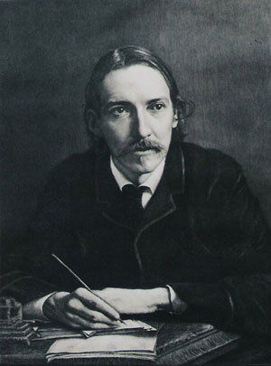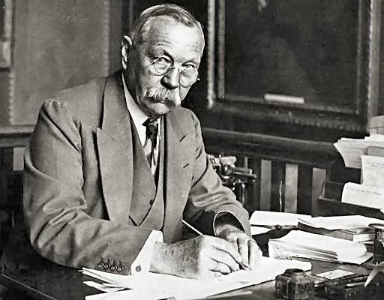
Роберт Льюис Стивенсон Артур Конан Дойль

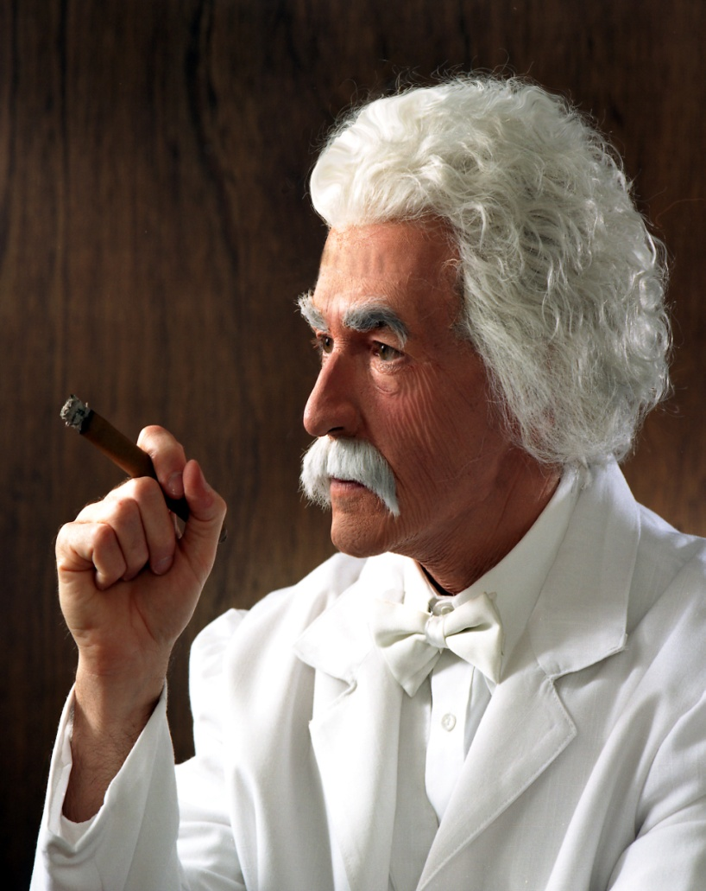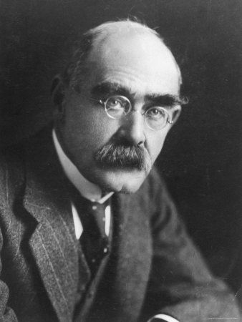
Марк Твен Редьярд Джозеф Киплинг

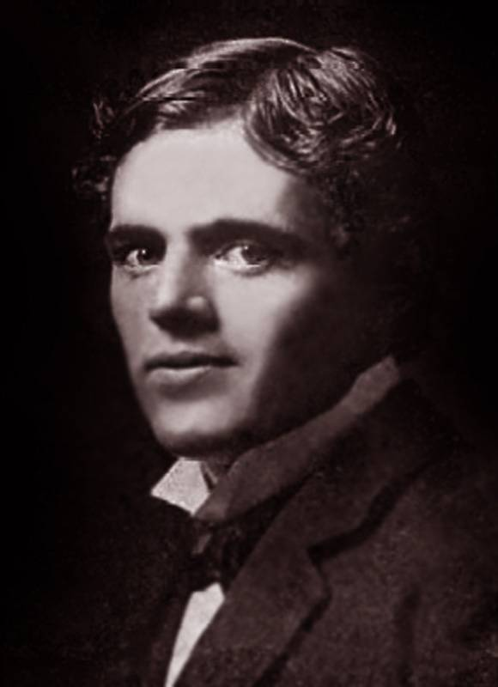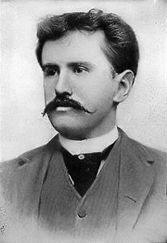
Джек Лондон О’Генри

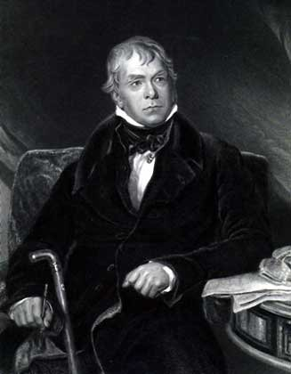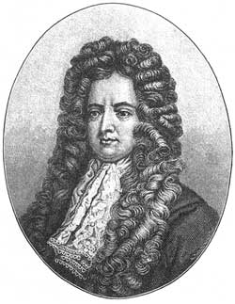
Вальтер Скотт Даниэль Дефо
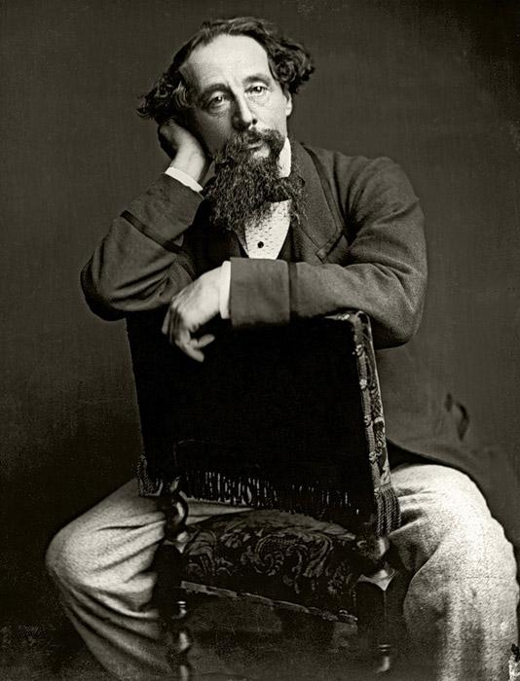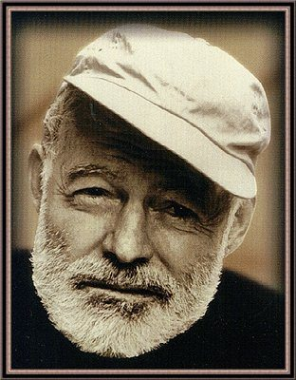
Чарльз Диккенс Эрнест Хемингуэй

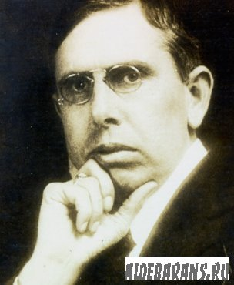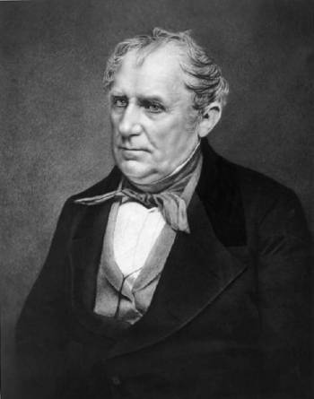
Теодор Драйзер Джеймс Фенимор Купер
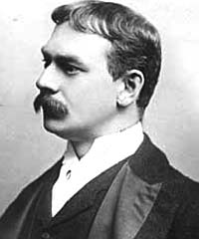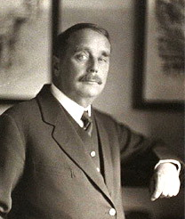
Джером К. Джером Герберт Уэллс

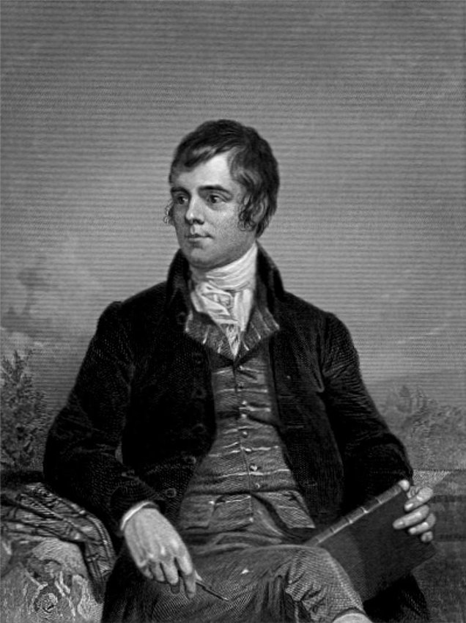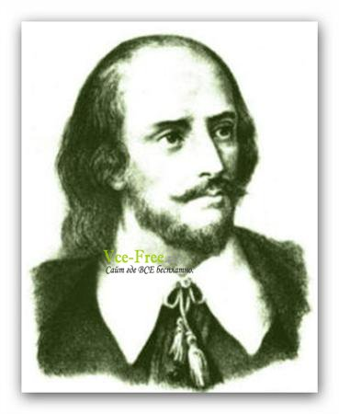
Роберт Бернс Вильям Шекспир
Фильмы
- «Один дома»
- «Миссия невыполнима»
- «Красотка»
- «Рембо»
- «Роки»
- «Звездные войны»
- «Терминатор»
- «Маска»
- «Матрица»
- «Титаник»
- «Челюсти»

Этапы игры
- Ответы на вопросы о Великобритании;
- Ответы на вопросы о США;
- Песни;
- Ответы на вопросы об англо-говорящих странах;
- Ответы на вопросы о литературе;
- Ответы на общие вопросы;
- «Чье это произведение?» (конкурс капитанов);
- Отрывки из литературных произведений;
- Достопримечательности по картинкам;
10. Фильмы;
11. Закончить пословицы и идиомы;
12. Перевести пословицы и идиомы;
13. Загадки; (конкурс для болельщиков);
14. «Угадай слово»;
15. «Кто автор?»
16. «Дай полное имя»;
17. «Раскодируй слово»;
18. Ответы по контурным картам;

TRANSLATE THE PROVERBS AND IDIOMS
- A bird in the hand is worth two in the bush.
- A great ship asks deep water. –
- To come out dry.
- Better die standing than live kneeling. –.
- To take the bull by the horn. –
- Too much knowledge makes the head bald. –
- Who keeps company with the wolf, will learn to howl. –
- When at Rome, do as the Romans do. –.
- To carry coals to Newcastle. –.
- Out of sight, out of mind. –.

TRANSLATE THE PROVERBS AND IDIOMS
- A bird in the hand is worth two in the bush. –
- A great ship asks deep water. –
- To come out dry. –.
- Better die standing than live kneeling. –.
- To take the bull by the horn. –.
- Too much knowledge makes the head bald..
- Who keeps company with the wolf, will learn to howl. –
- When at Rome, do as the Romans do. –.
- To carry coals to Newcastle. –
- Out of sight, out of mind.-.

TRANSLATE THE PROVERBS AND IDIOMS
- A bird in the hand is worth two in the bush. – Лучше синица в руке, чем журавль в небе.
- A great ship asks deep water. – Большому кораблю – большое плавание
- To come out dry. – Выйти сухим из воды.
- Better die standing than live kneeling. – Лучше умереть стоя, чем жить на коленях.
- To take the bull by the horn. – Взять быка за рога.
- Too much knowledge makes the head bald. – Много будешь знать – скоро состаришься.
- Who keeps company with the wolf, will learn to howl. – С волками жить – по волчьи выть.
- When at Rome, do as the Romans do. – В чужой монастырь со своим уставом не ходят.
- To carry coals to Newcastle. – Ездить в Тулу со своим самоваром.
- Out of sight, out of mind. – С глаз долой – из сердца вон.

ENCODE THE WORD
16, 1, 18, 12, 9, 1, 13, 5, 14, 20 –

16, 15, 16, 21, 12, 1, 20, 9, 15, 14 –

ENCODE THE WORD
16, 1, 18, 12, 9, 1, 13, 5, 14, 20 –

16, 15, 16, 21, 12, 1, 20, 9, 15, 14 –

ENCODE THE WORD
16, 1, 18, 12, 9, 1, 13, 5, 14, 20 –

16, 15, 16, 21, 12, 1, 20, 9, 15, 14 –

ENCODE THE WORD
16, 1, 18, 12, 9, 1, 13, 5, 14, 20 –

16, 15, 16, 21, 12, 1, 20, 9, 15, 14 –

ENCODE THE WORD
16, 1, 18, 12, 9, 1, 13, 5, 14, 20 –

16, 15, 16, 21, 12, 1, 20, 9, 15, 14 –

ENCODE THE WORD
16, 1, 18, 12, 9, 1, 13, 5, 14, 20 –

16, 15, 16, 21, 12, 1, 20, 9, 15, 14 –

Роберт Льюис Стивенсон
Артур Конан Дойль

Марк Твен
Редьярд Джозеф Киплинг

Джек Лондон
О’Генри
Вальтер Скотт
Даниэль Дефо
Чарльз Диккенс
Эрнест Хемингуэй

Теодор Драйзер
Джеймс Фенимор Купер
Джером К. Джером
Герберт Уэллс

Роберт Бернс
Вильям Шекспир

