Достопримечательности Лондона

Sights of London
- Прочитайте информацию и ответьте на вопросы письменно.
St.Paul’s Cathedral
What is the cathedral famous for?
Who built it?
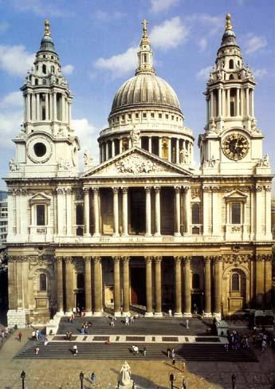 | It is one of the symbols of London. It was built in 1710 by a great English architect Christopher Wren. This cathedral is famous for the Whispering Gallery: if you whisper anything on one side of the gallery, your words will be heard very clearly on the other side.  Every year a special ceremony is held on the occasion of the Monarch’s birthday.
Westminster Palace (Big Ben)
When was it constructed?
Which tower is the most famous? Why?
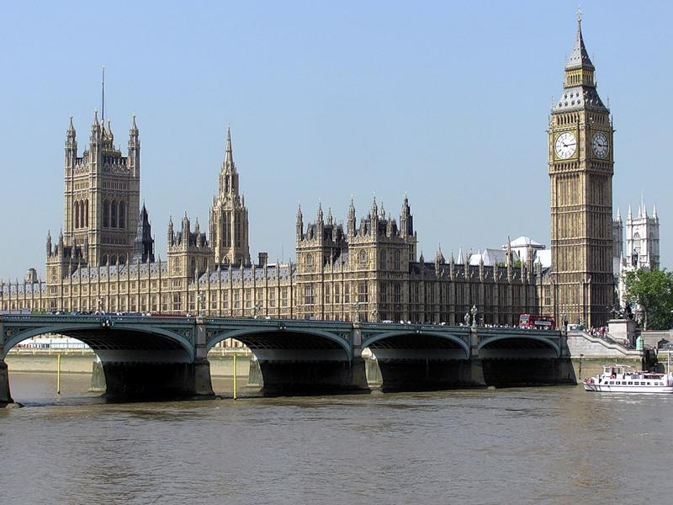 | Westminster Palace is the seat of British Parliament. Another name is the Houses of Parliament. It was constructed in the 11th century. It contains 1,100 rooms, 100 staircases and 11 halls. It has got 3 massive towers: the Victoria Tower, the Middle Tower and St.Stephen’s Tower. The last Tower is the most famous, because it houses the clock called Big Ben.  The Houses of Parliament consist of the House of lords and the House of Commons.
Westminster Abbey
Who was the first monarch crowned there?
Who is buried there?
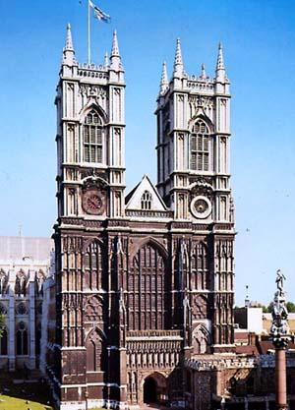 | It’s the oldest and the most important church in England, the official church of the British Monarch. The coronations take place there and many kings and queens are buried there. The first Monarch who was crowned there was William the Conqueror in 1066. (Вильгельм Завоеватель)  Here there is the Poet’s Corner where there are monuments to some great British writes: William Shakespeare, Robert Burns, Jane Austen and others.
The Tower of London
Who founded the Tower of London?
What can we see there now?
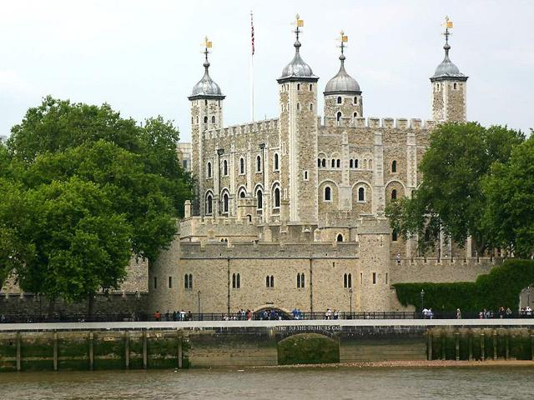 | Today its official title is “Her Majesty’s Palace and fortress of the Tower of London”. It was founded by William the Conqueror in 1078 as a fortress. Later it was the Royal residence, the Royal Observatory, a prison, a zoo. Now it is a museum, which contains the national collection of armour and the Crown Jewels.
Trafalgar Square
What can we see in the centre of Trafalgar Square?
What do the lions symbolize?
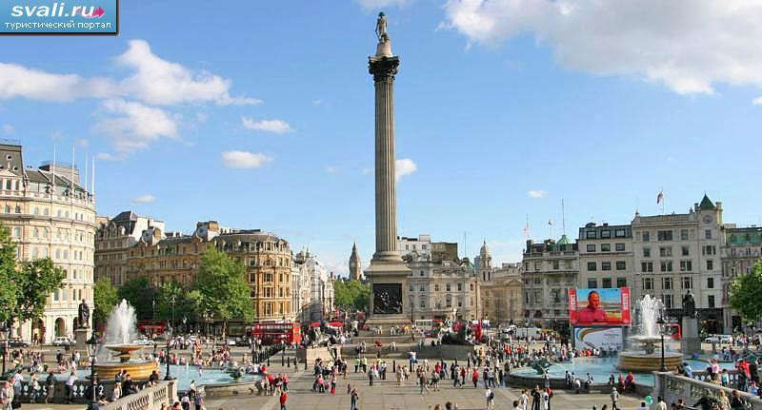 | This is the largest square in the central London. In the centre of it there is Nelson’s Column. It was created in the memory of the victory of Admiral Nelson over Spain in 1805 at Cape Trafalgar. The column is 50 metres high. Around the column there are 4 bronze lions. They symbolize courage.
Parks of London
What is the oldest park in London?
What can we see in Hyde Park?
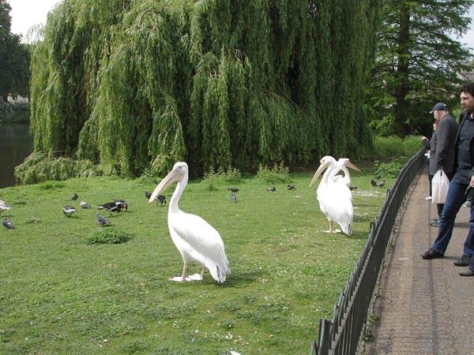 | London is a green city with lots of parks and gardens. The three best known parks are: Hyde Park, St.James’s Park, Kensington Gardens. The most popular attraction in Hyde Park is The Diana Memorial Fountain in the shape of a heart. St.James’s Park is the oldest park in London. It is famous for the Queen Victoria Memorial.
Buckingham Palace
How many rooms are there?
When is this Palace open for visitors?
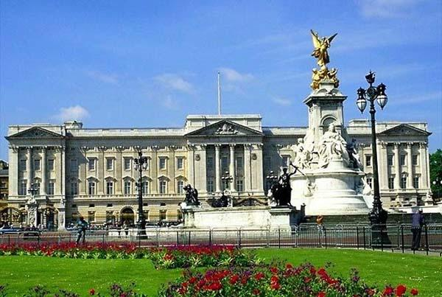 | It’s the official residence of the British Monarch. It contains 400 rooms, a swimming-pool, a tennis-court, and a large garden with a lake. This Palace is open for visitors during August and September when the Queen is on holiday.  In summer the Queen gives three garden parties which usually start at 4 pm. People who have done good work in different fields: scientists, politicians, sportsmen are invited there.
2.Зайдите на ссылки и решите тесты по теме
https://testedu.ru/test/english-language/8-klass/london-i-its-sights.html
https://english-study-cafe.ru/index.php/students/index.php?option=com_content&view=article&catid=121&id=679

