ЗКО, г.Уральск СОШ№32
учитель английского языка I категории Пушанова.Н.З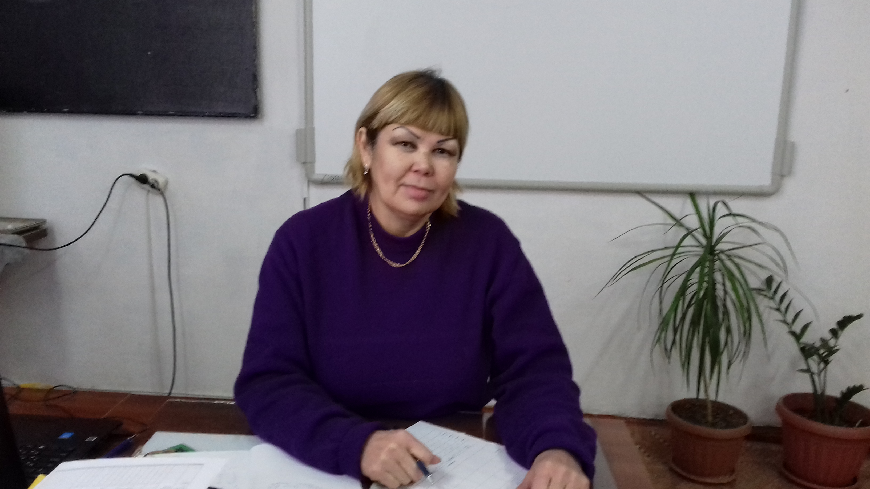
7th grade
The theme: «Eating in Britain» Aims of the lesson: educational: to form skills in monologue and dialogue speech, to enrich pupils’ vocabulary on the given theme; developing: to develop pupils’ abilities in speaking through group work, communicative competence, to develop their creative abilities through different kinds of activities; bringing-up: to teach pupils to respect other cultures, to broaden pupils’ minds, to bring up the feeling if international friendship. Methods of the lesson: interactive, communicative approach. Type of the lesson: introductory. Equipment: cards, an interactive board. video materials. pictures.
Procedure of the lessons.
I. Org moment. Good morning, children I am very glad to see you. How are you? Cl. we are fine thank you. Please sit down. Who is on duty today? What date is it today? What is the weather like today? Who is absent today? Well let’s begin our lesson.
II Training
Come here let’s make a circle now. Your task is to call your name using adjectives for the first letter of your name. Describe your mood. No thank you sit down please. Now you see I’ll divide you into three groups.
III. Brainstorming. Now pupils you know at the previous lesson we spoke about food and the name of Kazakh dishes I’ll give you cards with questions your task is ask this questions to the next group.
1. What is your favourite food?
2What is your favourite meat dishes?
3 What do you usually have for breakfast?
4 Do you like tea or coffee?
5 Is it good to eat porridge for breakfast?
6 What is popular food in your family?
7 Why are fresh fruits and vegetables better for you? 8What do you like to eat for supper? 9What do you usually prepare for guest 10What soup do you prefer? 11Name some horse meet delicatessen. 12Do you like junk food?
IV Checking up the home task. What was your homework (to write recipe.) Now let’s check up the home task.
I asked you to make your project. You had to choose a dish you like. Collect information about it and write its recipe. No come to the blackboard. Show us your recipe and describe it.P1 (to prepare project)
V. Warming up.
1. I like bread and I like cheese
I like coffe I like tea
I like butter I like sugar
I like juice
I like milk and I like fish
I like meat and I like honey
I like honey
2. I like cabbage, I like eggs
I like carrots, I like grapes
I like orange, I like apples
and bananas
And potatoes I like
Cucumbers, tomatoes
Biscuits, pears, sausage, sandwich
I like Too.
Now look at the blackboard I prepare you some songs about food (the words of song are on the interactive board). Pupils once or twice read and then sing a song Food. VI. Introduction of the new lesson. What are we going to talk about? P1, 2 we speak about food. Yes right you are. Do you remember proverbs about food? P1 P2 P 3 : let’s remember proverbs
1 Live not to eat but eat to live.
2 Appetite…
3 Голод . лучший повар .
4 Жарты нан-жоқтан жақсы.
5 An apple a day takes the doctor away. Now give me the Russian and Kazakh equivalent. Thank you. Today we’ll speak about the eating in great Britain and what food is popular we’ll remember national dishes of the UK, make a dialogue, read the text, and we’ll talk about English breakfast lunch dinner, and supper. What do you know about British food. I’ll give you cards match the Russian equivalent. And make 2 or 3 statements with these words.
VII. New words (look at the blackboard). Let’s revise our words according to the theme. Now repeat after me. Cuisine -кухня fish and chips – рыба и чипсы
bacon - бекон
ham - ветчина
sausage - колбаса
scrambled eggs - яичница
mutton - баранина
toast - тосты
marmalade - мармелад
cornflakes with milk – кукурузные хлопья
meat - мясо
milk - молоко
potatoes - картошка
hamburgers – гамбургеры
roast beef – жареная говядина
Steak- кусок
Yorkshire pudding- английский пирог
oatmeal- овсяная каша
fried eggs – жареная яичница
sandwiches- бутерброд
vegetables-овощи VIII. Group work (I’ll give you the text read the text and find out these words in the text) 1 1st group Match topics from 1 till 4 with paragraphs A-D in the text. Write A-D in the boxes. 2nd group: make up a dialogue 3d group: has chance to compare Kazakh traditions of having dish with the British ones. Eating in Britain. English dish consist of…….. Kazakh dish concludes….. IX. Video. It’s time to listen the text about English tastes.
XX. Questions..Let’s use the methods yes or no answer the questions.
1. Is the usually English breakfast consist of: toast, marmalade, scrambled eggs, bacon?
2. Do they eat for Breakfast sausages?
3. Do they eat cornflakes with milk?
4. Do they eat fish and chips for lunch? Yes they do.
5. Do they like to drink cream tea with scones and jam?
6. Do they eat turkey for breakfast? No they don’t.
7. Is the most popular drink in Britain coffee? No.
8. Do they drink mineral water for supper?
9. Do they drink juice for breakfast?
10. Do we have the same dishes in our national cuisine? You know that people can’t live without food. Nowadays people want to the strong and healthy and we must know what we should eat and what we shouldn’t eat. Let’s begin. P 1 I think you should eat porridge for breakfast. P2 P3 P4 2Now look at the blackboard let’s revise should and shouldn’t.
IX. Grammar revision: Let’s revise grammar material with should and shouldn’t .Look at the blackboard. I’ll give you cards your task to write advise with should or shouldn’t. Are you ready. the first group begin…
XI. Conclusion: let’s analyze our lesson. Using the method Conquering poetry: 1 word (a subject or a noun)
2 words (adjectives) that describe the first word
3 words (action verbs) that relate to the first word
4 words (feelings or a complete sentence) that relate to the first word
1 word (a synonym of the first word or a word that sums it up)
Here is the example: 1. Dish
2. Delicious, tasty
3. make, cook, prepare .
4 .food.
XII. Getting up the home task : be ready to present what the British cuisine is like.
XIII. Reflection.
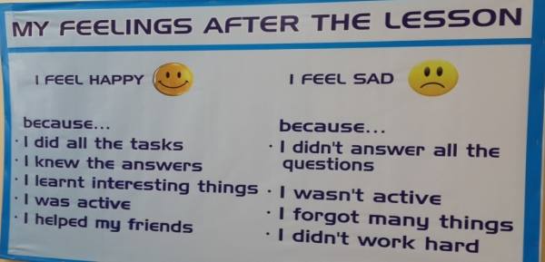
Thank you for the lesson You’re so active Good luck.

Город Уральск

