HOW TO TEACH AUXILIARY VERB AT SCHOOL LESSONS ?

What are Auxiliary Verbs?
The definition of auxiliary verbs are verbs which form the tense, mood and voice of other verbs. They are also known as 'helping verbs'.
A simple definition of a verb is a word that is used to describe an action or occurrence.
The 3 most common auxiliary verbs are: 'be, 'have, do'.
- To Be: am, is, are, was, were, being, been, will be.
- To Have: has, have, had, having, will have.
- To Do: does, do, did, will do.
The modal verbs 'can, could, may, might, must, ought to, shall, should, will, would' are also included as auxiliary verbs.
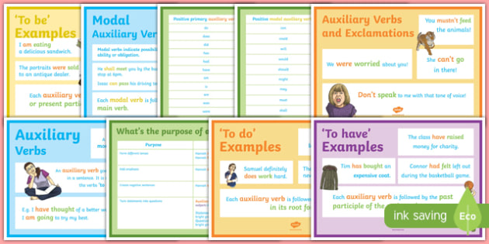

Examples of 'Be' Auxiliary Verbs?
'Be' can be an auxiliary verb or the main verb in a sentence.
In the examples below the, 'be' auxiliary verbs are in bold.

Used in a progressive sentence:
- I am going to school.
- She is playing basketball.
- They have been learning about verbs.

Used in a passive sentence:
- I was going to school.
- She was playing basketball.
- This lesson on verbs has been interesting.

Examples of 'Have' Auxiliary Verbs?
'Have' is used to create the 'present perfect tense' and is always followed by the past participle.
'Has' is used to make it third person singular.
'Had' is used to make a sentence past tense. It explains an action that started in the past but is still ongoing into the present, known as 'past perfect tense.'

Used in a perfect sentence:
- I have been walking to school.
- We have learnt a lot today.
- They had been the best students.

Examples of 'Do' Auxiliary Verbs?
Auxiliary verbs can be used to make questions and negative statements.
'Do' and 'does' are frequently used to make questions and negatives.
'Did' is used to replace 'do' and 'does' to make a sentence past tense.

Examples of statements:
- I do my schoolwork.
- You do your schoolwork.
- We do our schoolwork.
- They do their schoolwork.
- He/she does their schoolwork.

Examples of questions:
- Do I want one?
- Do you want one?
- Do we want one?
- Do they want one?
- Does he/she want one?

Examples of negative sentences:
- I do not. (I don't)
- You do not. (you don't)
- We do not. (we don't)
- They do not. (they don't)
- He/She Does not. (he/she doesn't)
