Методический материал для создания игры-викторины на игровой платформе Kahoot
How well do you know English-speaking countries?
- The capital of the United Kingdom is...... | 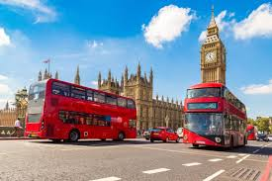
- London | - New York
- Washington | - Ottawa
- Which country belongs to the UK? | 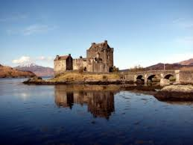
- Ireland | - Scotland
- New Zealand | - Australia
- Montreal, Toronto and Vancouver are the cities in the USA. | 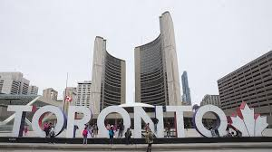
- True | - False
- Auckland, the City of Sails, is in | 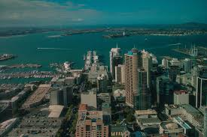
- Canada | - Australia
- New Zealand | - Great Britain
- Koalas are from | 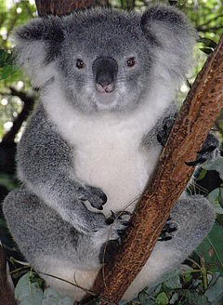
- Canada | - The USA
- Australia | - The United Kingdom
- Kiwi birds live in | 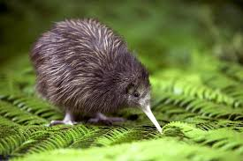
- Australia | - Canada
- The USA | - New Zealand
- The Tower of London is in the USA | 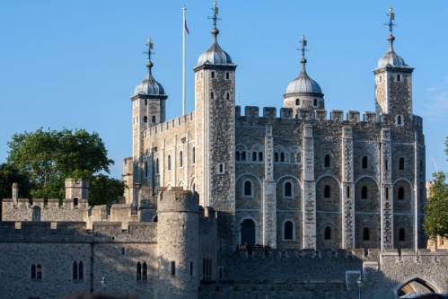
- True | - False
- Belfast, Cambridge and Manchester are the cities of | 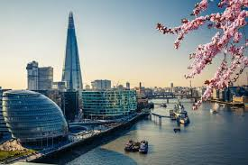
- the UK | - Canada
- the USA | - Ireland
- The book "Winnie- the- Pooh" is from the USA | 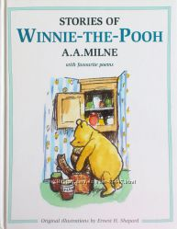
- True | - False
- The Qween lives in | 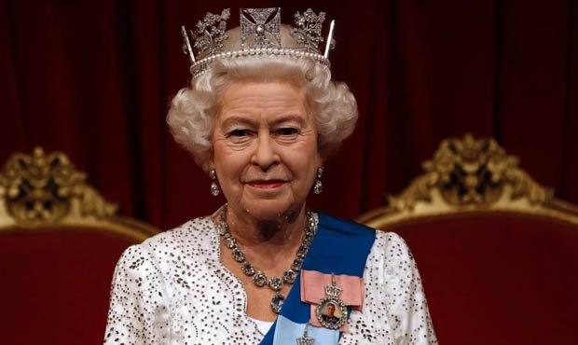
- New Zealand | - Canada
- Australia | - the United Kingdom
- This is the flag of | 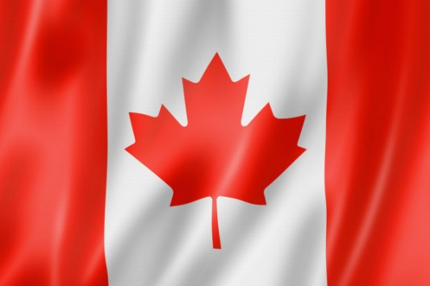
- Canada | - Australia
- New Zealand | - Great Britain
- New York is the capital of the USA | 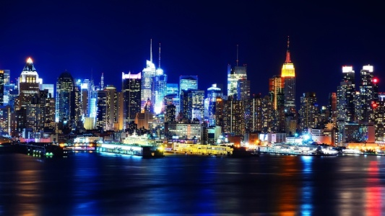
- True | - False
- Where's Big Ben? | 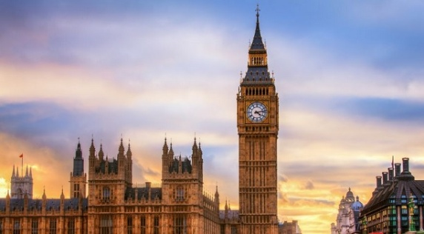
- Ottawa | - London
- Washington | - Cambridge
- The capital city of Canada is Washington. | 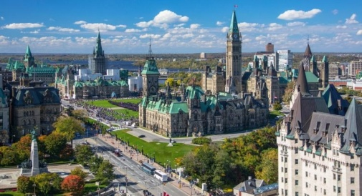
- True | - False
- In England they like to drink
- Tea | - Cofee
- Coke | - Juice
- What is the official monetary unit of Great Britain?
- Rouble | - Dollar
- Euro | - Pound sterling
- What is the most popular food of English? | 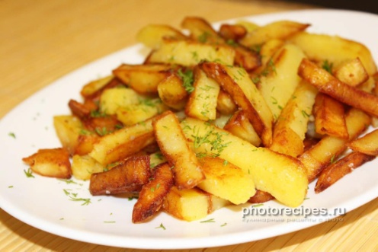
- Salad | - Fish and chips
- Jam | - Soup
- They celebrate Christmas on the
- 31st of December | - 25 of December
- 1st of January | - in spring
- Great Britain is situated in America. | 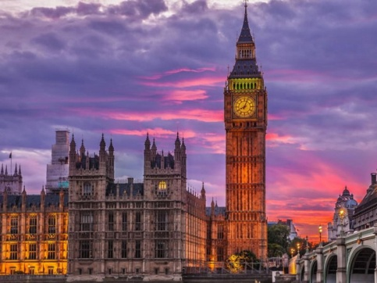
- True | - False
- The most popular colour of Halloween is | 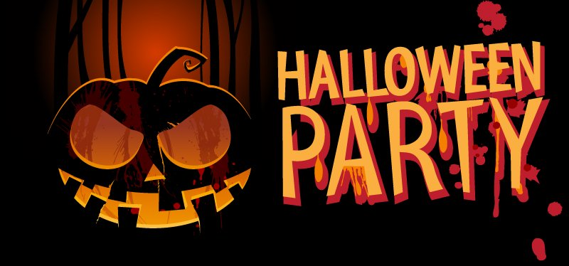
- black | - blue
- white | - green

