Конспект открытого урока
Школа: МКОУ «Мискинджинская средняя общеобразовательная школа им. М.Ахундова»
Дата: 25.11.2017г.
Класс: 5 «а»
Учитель: Амрахов Видади Эрзиманович
Тема: Halloween.
Тип урока: комбинированный
Цели:
1. Практическая: формирование навыков говорения
2. Развивающая: развивать и укреплять интерес школьников к изучению английского языка, расширить их кругозор, развивать внимание, память.
3. Образовательная: расширение лингвистического кругозора учащихся.
4. Воспитательная: воспитывать толерантное отношение к чужой культуре, более глубокое осознание своей культуры через контекст культуры англоязычных стран.
Задачи:
1. Ввести и отработать новую лексику.
2. Познакомить учащихся с праздником Хэллоуин страны изучаемого языка, с традициями и обычаями этой страны.

Литература:
1. Дзюина Е.В. Театрализованные уроки и внеклассные мероприятия на английском языке: 1-4 классы. – М.: ВАКО, 2006. – 176с.
2. Повторение и контроль знаний по английскому языку на уроках и внеклассных мероприятиях. 2-11 классы. Тренировочные упражнения, контрольные работы, сценарии мероприятий /Е.В. Сапункова. – М.: Глобус; Волгоград: Панорама, 2008. – 208 с .

Этапы урока | Деятельность учителя
1. Орг. момент | Good morning, boys, girls and our guests! Sit down and make yourself comfortable. And begin our lesson.
2. Вступительное слово | Welcome to our Halloween party! On the thirty first of October is Halloween. A long time ago people were afraid and stayed at home on Halloween. But now in Britain it is a day for fun. There are a lot of parties that night. Don't be afraid if you see ghosts, goblins and black cats today at our party.
3. Сообщение темы урока | - Dear friends. Today we are going to speak about Halloween. We will play word games, read text, new words and know about Halloween and its traditions and do some invitations for our lessons.
4. Ведение лексики | - Try to remember the words. Let us begin with the reading these words:  Return - возвращаться  Soul - душа  Dead - мёртвый  Dress up - одевать  Witch - колдунья  Ghost - привидение  Devil - чёрт  Bat – летучая мышь  Goblin - домовой  Beggar - нищий  Custom - обычай  Skeleton - скелет  «Trick or treat» - угости или сыграем злую шутку  Lantern – фонарь  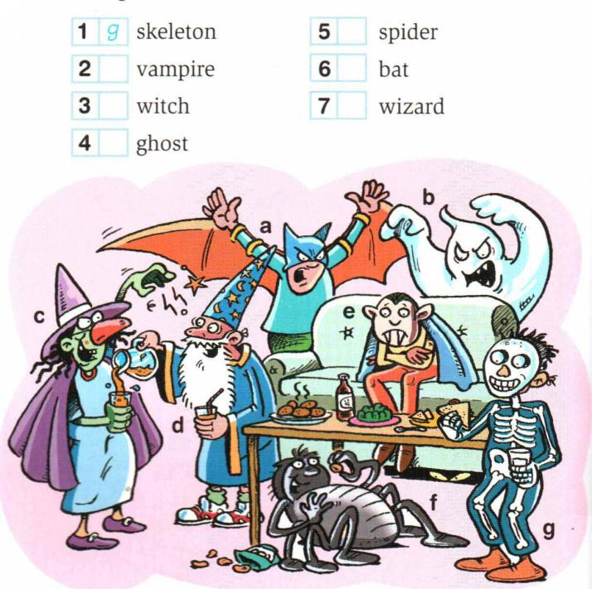  - Now, Number the pictures.
5. Чтение текста | Now read the text about Halloween traditions one by one.  Halloween  On the thirty first of October is Halloween. This festival celebrates the return of the souls of the dead who come back to visit places where they lived. In the evening there are lots of Halloween parties. People dress up as witches, ghosts, devils, cats or bats. Houses are decorated with pumpkins with candles inside them. Some children follow the American custom called Trick or Treat.  They knock at your house and ask, «Trick or treat? ». If you give some money or some sweets, they go away. If not, they can play a trick on you, like splashing water in your face.  No Halloween party is complete without a scary story. Usually people crowd together around a fire on Halloween night. And one person tells a scary story in a low voice.
6.Работа после текста | -Name 3 special things people do on Halloween.  -Complete the sentences.  1. Halloween is on the … .  2. People dress up as … .  3. Houses are decorated with … .  4. Some children knock at the house and ask «…».  5. If you do not give any money or sweets, they … .  6. People usually tell … on Halloween night.
7. Аудирование и физминутка | -Listen to this scary story.  In a dark, dark wood there is a dark, dark house.  And in a dark, dark house there is a dark, dark room.  And in a dark, dark room there is a dark, dark cupboard.  And in a dark, dark cupboard there is a dark, dark box.  And in a dark, dark box there is a dark, dark g-h-o-s-t.  -Tell this story all together. (физминутка с движениями)
8. Закрепление изученного | OK. Well done. Now be careful with the next task. You have to do some exercises.  a) Pick out the right words and read the sentences.  At Halloween children dress up as fairies, witches, father-frosts, ghosts.  They visit their teachers, neighbors, parents.  They cry: Happy Birthday, Merry Christmas, Trick or Treat.  The grown-ups must give them a pudding, a gift (present), fruit, sweets.  The children dance, sing, knock at the door.
b) Let’s compose the instructions for the Halloween lantern.
Take a huge yellow pumpkin.
Cut eyes.
Cut a nose and a mouth.
Put the candle inside the pumpkin.
Light the candle.
Put the pumpkin near or in the house.

That’s quite right. Try to make a Jack O’Lantern at home.
9. Чтение стихов | Some pupils want to recite poems.  Ghosts and witches, ghosts and witches!  Gather here! Gather here!  Halloween is coming! Halloween is coming!  Can, t you here? Can, t you here?  Bats and rats and witches and cats,  Skeletons in bowler hats.  Don’t be scared! It is Halloween –  Spooks and spirits can be seen!
10. Составление приглашения | The next task. You need to write Halloween invitations to our friends.  ( раздать пригласительные открытки)  And send them
11.Домашнее задание | Please take out your homework notebooks.  The homework for the next lesson is to answer the questions.  When do people celebrate Halloween?  What do children shout when they walk door to door?  What are the most popular treats?  What are the traditional colours of Halloween?  What is a Jack O’Lantern?  What costumes do children wear on Halloween?  What is the traditional meal of this holiday?
12. Итог | Дети в красочных костюмах стучатся в дверь и произносят “Trick or treat!” три раза. Хозяева угощают детей, а на третий раз ничего не дают и этот ребёнок лопает воздушный шар, т.е. наказывает.  Treat  Trick or treat, Trick or treat,  Give us something good to eat.  Give us something sweet to take.  You had better do it quick.  Or we will play a trick.  Trick or treat, Trick or treat,  Give us something good to eat.  Thank you for your attention and your work. Today we have learnt some more facts about American traditions and Halloween. I am giving you a four. The lesson is over.

