For the 1st Grade
Theme:
Let’s Play (Review)

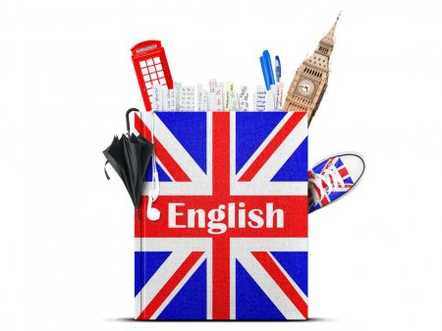

By the English Teacher
of the school №50
Nabiyeva Nigina

Kattakurgan 2019-2020

Lesson Plan for the 1st Grade
Date: 4.12.2019
Lesson: Let’s Play

Type of the lesson: Revising, Lesson-competition
Class management: Plenary, Individual work, group work

Objectives:
Educational: to recycle the knowledge of various themes;
Developing: to enable pupils to work as a team to achieve a good result;
to develop listening and speaking skills
Socio-cultural: to raise awareness of the importance of teamwork to achieve good results

Outcomes:
By the end of the lesson pupils must
- be able to remember the previous vocabulary.
-be able to ask and answer the questions about likes

Materials: books, cards, pictures, projector, DVD of the book

Lesson Plan
Stages | Content | Method | Timing
Warm-up | Greeting/ Game “I can” | Plenary, Energizing | 5 minutes
Activity 1 | Let’s Count | Plenary, Watching slides | 2 minutes
Activity 2 | Dividing Into groups | Choosing cards | 1 minute
Activity 3 | “Little Numbers” Song | Listening and Singing | 3 minutes
Activity 4 | Numbers game | Group work | 7 minutes
Activity 5 | Game “Hit the fly” | Group work | 10 minutes
Activity 6 | Game “Who is Quicker” | Vocabulary Review Group work | 5 minutes
Activity 7 | Color the picture | Individually | 5 minutes
Activity 8 | Math Quiz | Working with cards | 5 minutes
Estimating & Giving h/w | Counting points | H/w Revising words | 2 minutes
Warm-up | Greeting/ Game “I can” | Plenary, Energizing | 5 minutes

Objective: to raise pupils’ interest, to energize them, to enable pupils to ask and answer questions about likes
The teacher greets the pupils
- Good morning, pupils!
- Good morning!
- How are you? Are you fine? Are you bad?
- We are (fine)!
- Ok, let’s start our lesson. Stand up! Now I will show you some actions you will tell me “I can …”
The teacher shows the pupils actions and the pupils repeat after the teacher. They should say I can and name the action. F.e. The teacher jumps, the pupils should say “I can Jump”. The teacher should help pupils to remember some actions.

I can jump
I can dance
I can sing
I can swim
I can blow
I can sleep
I can fly
I can run

Excellent! And now I want to ask you some Questions.
What is this? (the teacher points to the picture with toys) The pupils say “Toys”
What toy do you like?
Pupils answer: - I like a ball.(I like a doll, I like a teddy-bear…)
-What is this? (the teacher points to the picture with fruits) The pupils say “Fruits”
What fruit do you like?
Pupils answer: - I like an apple.(I like a pear, I like a banana…)
-What is this? ? (the teacher points to the picture with animals) The pupils say “Animals”
What animal do you like?
Pupils answer: - I like a dog.(I like a cat, I like a tiger…)

Activity 1 | Let’s Count | Plenary, Watching slides | 2 minutes
Objective: to check weather pupils can count correctly
The teacher shows the slides. On the slides there are different objects. Pupils should count the objects correctly.
- How many pencils are there? Let’s count! One, two, three, four, five. Five pencils! Good! est.

Activity 2 | Dividing Into groups | Choosing cards | 1 minute
Objective: to enable pupils to work in groups
The teacher offers pupils to take cards. They are in the box or in the basket. There are two types of cards- apples and bananas, those pupils who choose apples will be in “Apple” group, Those who choose bananas will be in “Banana” group. To identify their places the teacher puts boxes with the images of banana and apple on the desks.
- Ok, kids. Now you should take cards.
- Apples, hands up! You will sit here. (They sit down on the first row) Bananas hands up! Come here. (They sit down on the second row)
- You are a Banana team and you are an Apple team.
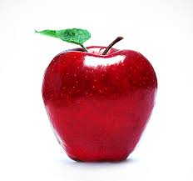

Activity 3 | “Little Numbers” Song | Listening and Singing | 3 minutes
Objective: to have fun with pupils, to have a rest
The teacher shows pupils a video.
The pupils listen and sins all together.
They show the numbers on their fingers
- And now stand up. Let’s sing a song.

One little, two little, three little numbers
Four little, five little six little numbers
Seven little, eight little, nine little numbers,
Ten little numbers!
Ten little, nine little, eight little numbers,
Seven little, six little, five little numbers,
Four little, three little, two little numbers,
One little number!

Activity 4 | Numbers game | Group work | 7 minutes
Objective: to enable pupils to think quickly and say numbers
The teacher asks one pupil from each team to come. They will compete with each other. The teacher shows them cards with numbers. The pupils must name the number as quickly as possible. There are numbers from 1 to 10. The pupil who says the number correctly and quickly gets a point (a candy to the group basket). When these two pupils finish, the teacher calls another pair of pupils.
- I need two pupils, one from each team. Welcome to the board, please. I will show you the numbers and you should say these numbers? Are you ready?

Activity 5 | Game “Hit the fly” | Group work | 10 minutes
Objective: to raise pupils’ interest, to repeat the decimals
There are cards of flies on the board. There are decimal numbers on the flies.
- Ok, pupils. And now I want to show you something! There are flies on the board!
Fly number ten, fly number twenty, fly number thirty, fly number forty, fly number fifty…
The flies are bad! We must hit flies!
The teacher demonstrates how to hit flies. He takes the fly-hitter, says the number and hits the fly
The teacher takes one pupil from each team to come to the board. They take two fly-hitters and listen to the teachers command. The teacher says the decimal “Fly number 20!” The pupils should hit the fly with this number. The pupil who does it quickly and correct wins and gets a candy to the basket.

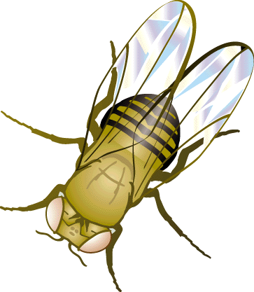
30
10
50
40
20

Activity 6 | Game “Who is Quicker” | Vocabulary Review Group work | 5 minutes
Objective: to raise pupils’ attention, to review all the previous words
The teacher asks the pupils to stand up in two lines “apples” and “bananas”
The teacher says the words from the previous topics. The pupils should say the translation of these words. Those pupils who say quickly and correctly stand to the end of the line, those who lose take their seats.

Words
Mother
Apple
Tiger
Cow
Grape
Father
Sister
Brother
Pen
Pencil
Door
Board
Pupil
Teacher
Lemon
Pear
Cat
Dog
Frog
Donkey
Elephant
Crocodile
Potato
Tomato
Cucumber
Ball
Girl
Doll
Boy
book
Toy
car
Activity 7 | Color the picture | Individually | 5 minutes
Objective: to calm down the pupils, to get them have a rest
The teacher gives the pupils handouts, They should color the pictures and count the objects on the pictures.
While other pupils are painting the teacher can arrange the next activity. Pupils can color and at the same time participate in this activity.
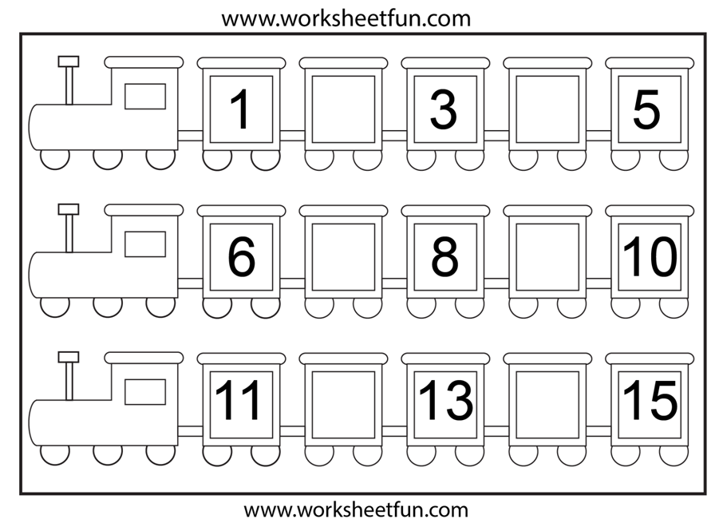
Activity 8 | Math Quiz | Working with cards | 5 minutes
Objective: to check if the pupils can calculate
There is a tree with cards- fruits. On the back of the cards there are tasks for calculations. Pupils should read the task and do it orally. If the pupil finds the correct answer he gets a candy for his team.
- And now we will pick fruits! You will come here, take one of the apples and read the task. You should say the answer correctly! Are you ready? Let’s stard!
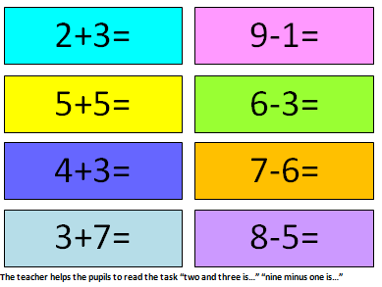

Estimating & Giving h/w | Counting points | H/w Revising words | 2 minutes
Objective: to sum up the results of the lesson, to estimate and give homework
Homework:
explain to the pupils that at home they should revise all the previous lessons and units to get prepared to the revision lesson.

