Контрольная работа Ф.И.________________________________Класс___________
- Вычеркни лишнее слово.
- Monday, board, timetable, pupil, desk
- English, Math, Sunday, Crafts, PE
- Tuesday, Friday, Thursday, Math
- Do sums, draw pictures, eat, skip
- Подбери правильный перевод и запиши его
- Do sums-
- Write numbers-
- Sing songs-
- Draw pictures-
- Skip-
- Talk to-
- Listen -
- Jump-
- Ответь на вопросы.
- What do you do in Math?

- What’s your favorite subject?
- ___________________________________________________________________
- What’s your name?
- ___________________________________________________________________
- Do you li
- sten songs in Music?
- ___________________________________________________________________
- Do you do sums in PE?
- ___________________________________________________________________
- Запиши числительные.
1___________________________________11______________________________________
2___________________________________12______________________________________
3___________________________________13________________________________________
4___________________________________14________________________________________
5___________________________________15________________________________________
6___________________________________16________________________________________
7___________________________________17________________________________________
8___________________________________18________________________________________
9___________________________________19________________________________________
10__________________________________20________________________________________
- Напиши кто чем занят используя настоящее время
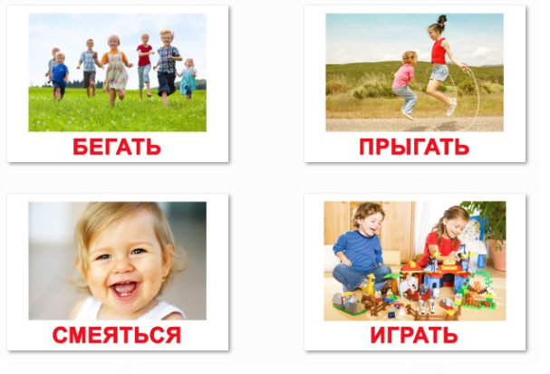
- Run,children___________________________________________________________

- Skip, boy and girl________________________________________________________

- Baby, smile___________________________________________________________

- Play, children____________________________________________________________

