TEST 7A (Module7)
Vocabulary
A Choose the correct word/phrase to fill in the gaps.
1. rush hour prime time 3. temper mood
a). I can’t believe they’re showing such violent films on a) John argues a lot and finds it difficult to control
… TV! Many young people watch at this hour. his … .
b) You should leave early tomorrow if you want to avoid b) Henry was exhausted and in no … to go out for
the … traffic. dinner.
2. test exam 4. grapevine headline
a) My brother passed his driving … yesterday. a) Have you read the … in this morning’s paper?
b) Do you prefer sitting a written or an oral … ? b) I heard through the … that John is getting a
promotion. Is that true?
B Fill in the missing word. There are two answers you do not need to use.
Media, impact, degree, certificate, deal, connect, edits, timetable, attention, newsreader, download, extension
5. Computers had a huge … on the 20th century. 10. Teen these days use their mobiles as a(n) … of themselves.
6. I can’t seem to … to the Internet for some reason. 11. The students who pass the exam are given a … .
7. The … on BBC1 is really handsome. 12. Multi- taskers are able to divide … between different activities.
8. It’s taking ages to … this file. 13. A photographer … pictures he has taken on his computer.
9. Have you got your new school … yet? 14. Alex can’t … with the stress of moving to a new area.

Grammar.
C Underline the correct item.
15. Ann may/has to leave school early tomorrow. She has a dentist appointment after school.
16. If Ben gets permission from his parents, he may/ must study in France next year.

17. Kate should have/ must have studied a lot for the history exam. He got very high mark.
18. Students mustn’t/ needn’t run in the school corridors. It’s against the rules.
19. You can/must raise your hand and wait before you ask a question.

D Fill in to, on, for, from, about.
20. I find it extremely difficult to concentrate … my homework when the television is on.
21. John comes … a very wealthy family.
22. My sister always blames me … things I never do.
23. Most bullies don’t care … the feelings of others.
24. The mum yelled at the boys because they had been mean … to the cat.
Everyday English
E Choose the correct response.
25. What’s the best way to do better in my exams? ___ A That’s the spirit.
26. How did you do in your maths test? ___ B You could revise more often during the year.
27. I’ll try my best to pass the history test next time. ___ C Pretty well.
28. Why don’t you get a full-time job and go to evening school?__ D How come?
29. Tom’s decided to postpone his studies for a year. __ E That’s easier said than done.

F Circle the most appropriate response.
30. Can I borrow your dictionary, please? A Not at all. B Of course.
31. Shall I carry this bag for you? A Yes, please. B No, you won’t.
32. We could go to the cinema tonight. A That’s a great idea. B No, we might not.
33. Will you explain this to me? A Yes, I should. B Certainly.
34. Could I ask you a question, please? A No, you wouldn’t. B Yes, of course.

Listening
G Listen to Mrs. Jenkins talk to her class before their final exam. For questions 1-6, choose A,B,C
35. This afternoon, students are sitting a(n)
A History exam.
B English exam.
C French exam.
36. The students are told
A there is one mark per question.
B there are three pages of questions.
C the exam has different types of questions.
37. What exam rule applies?
A Students must print their name on every page.
B Students cannot leave the room.
C Students can look at the course text book.
38. What advice does Mrs. Jenkins give her students?
A They shouldn’t guess if they don’t know the answer.
B. They should not forget what they have learnt about essay structure.
C They should finish early so they have time to look back for mistakes.
39. The students are told not to worry because
A they are capable of passing the exam.
B the exam is easy.
C they can retake the exam if they don’t pass.
40. At five minutes to two, Mrs. Jenkins says that the students can
A start writing.
B Look at the questions.
C put their name on the exam.

Reading
H Read the text and match the phrases (A-F) to the gaps (41-45). There is one extra phrase.
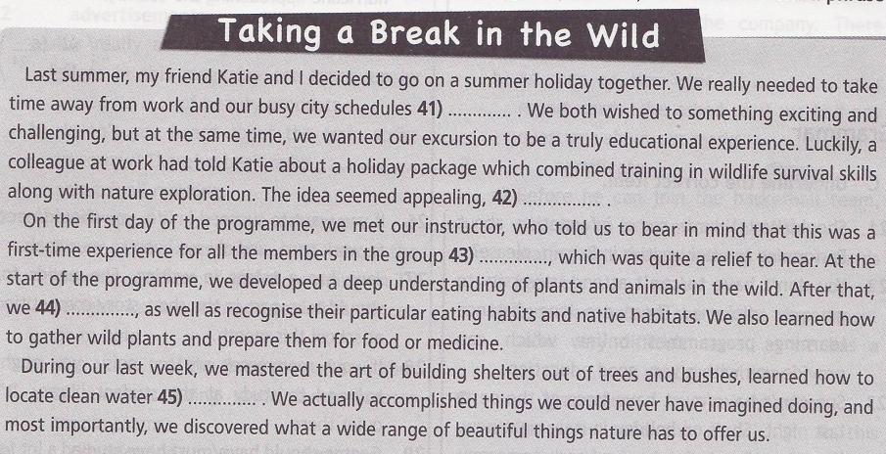

A so we set off the following week for our exciting adventure
B and do something different for a change
С went on to learn how to identify different species of animals
D but we weren’t very keen on the idea at first
E and build fires just by rubbing two sticks together
F and that everyone could learn at their own pac

KEY TO TEST
TEST 7A
A 1 a) prime time 3 a) temper
b) rush hour b) mood
2 a) test 4 a) headline
b) exam b) grapevine

B 5 impact 10 extension
6 connect 11 certificate
7 newsreader 12 attention
8 download 13 edits
9 timetable 14 deal

C 15 has to D 20 on
16 may 21 from
17 must have 22 for
18 mustn’t 23 about
19 must 24 to

E 25 B F 30 B
26 C 31 A
27 A 32 A
28 E 33 B
29 D 34 B

G 35 B H 41 B
36 C 42 A
37 C 43 F
38 B 44 C
39 A 45 E
40 B

