Activity 1
Materials: battery cell, an iron nail (5cm long) a steel nail, a switch, steel pins connecting wires and insulated copper wire.

· Draw a circuit diagram on the board.
· wind an insulated copper wire very closely over the iron nail. this makes a coil.
· attach the connecting wires to the two ends of the coil and connect them to battery cell through a switch.
· keep the switch off and bring some steel pins near one end of the nail.
Question: Does the nail attract them?
· turn the switch on and see if the nail attracts the pins now.
Question: predict what will happen if the current is switched OFF.
· Now turn the switch OFF to verify your prediction.
· Now repeat the same procedure with a steel nail and find out the difference.
· Question What do you conclude from this activity?
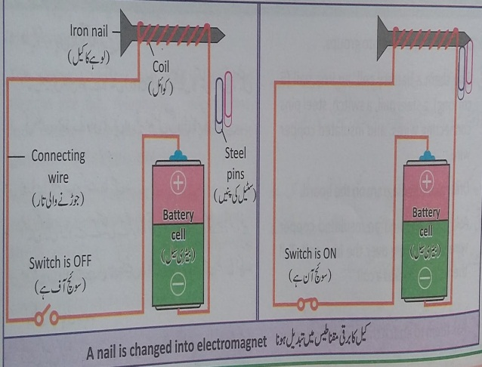
After their response tell them that nails can be made electromagnets by passing current through a coil. Iron nail is magnetized temporarily but steel nail is magnetized permanently when placed in a current carrying coil.

Activity 2
Materials: battery cell, a disc shaped magnet, two safety pins and pieces of wire.
Do:
• Wind the insulated wire to form a coil.
• Take safety pins and bend them with the help of pliers.
Mount the bent safety pins on a wood block and place the coil between safety pins as shown in figure
• Attach the wires from battery holder to the bent safety pins and place battery cell into the holder.
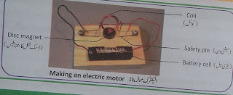·
Place a magnet on top of the wood block just underneath the coil.
Give a spin to the coil gently to get the motor started. By this, it will start rotating.
When a current carrying coil is place in magnetic field, a force acts on it which moves it in and out and the coil rotates. Electric generators and motor work on this relationship between current and magnet force.

Activity 3
· Identify the devices which use electromagnets.
· Present their findings in class discussion.
· Electromagnetic devices on the board and discuss about it.
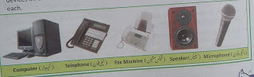

Assessment | Score |  |  |  |  | Feedback
 | 1 | 2 | 3 | 4 | 5
When an ordinary iron nail is placed inside a current carrying coil, will it become a temporary magnet or a permanent magnet?
2. Which material can be magnetized permanently with the help of electric current?
3
4.

. Can we say that magnet compass is an electromagnetic device?
How can an iron nail be made a magnet by electric current?
5.

Where are electromagnets used?
Homework task | List at least seven devices present at their homes in which electromagnets are used.

