Long-term plan unit: My pets and wild animals |  |  | School : 137
Date: 15.12.2017 |  |  | Teacher name: Kenzhebek Bulbul
Grade: 1 |  |  | Number present: |  | absent:
Theme of the lesson |  |  | Pets and wild animals
Learning objectives(s) that this lesson is contributing to |  | 1.S1 make basic personal statements and simple statements about objects  1.L1 recognise short instructions for basic classroom routines spoken slowly and distinctly  To consolidate the language of the module : to develop fine motor skills through craftwork; to produce a project about their toys
Lesson objectives |  | All learners will be able to:
- listen and repeat the transports
Most learners will be able to:
- recognise and name some transports
Some learners will be able to:
- recognise and name all transports
Success criteria |  | to name 5 objects correctly
Value links |  | Good citizenship and positive behavior
Cross curricular links |  | Geography
Thinking skills |  | Counting
Previous learning |  | Commands
Plan
Plannedtimings | Planned activities (replace the notes below with your planned activities) |  |  | Resources
Beginning  5 minutes  10 minutes | 1 T:Good morning , children  Cl: Good morning, good morning  Good morning to you!  Good morning . good morning  We are glad to see you!  2. Review Commands …  3. Phonetic drill:  On the board there are some letters. I show one by one, pupils need name the letters.  Dd Oo Mm Ss Pp Cc Tt Rr Gg  Words for the game: train, dog, duck, parrot, hamster, cat, kite, robot, doll.  Revision colours: white, blue, red, green, yellow  I show pictures and ask: “What colour is it?”. Pupils name the colour  Today we talk about pets. Our theme is “My pet”  Presentation  New words:  On the board there are pictures with new words.  A dog a cat a hamster a parrot a horse  - I name the words, pupils repeat after me (word by word)  - Pupils answer the question “What’s this?” for each picture  - Reading the words after me  - Working with book. Page 49 |  |  | Visual aids: rabbit, fish, cat, dog, mouse,parrot,spider  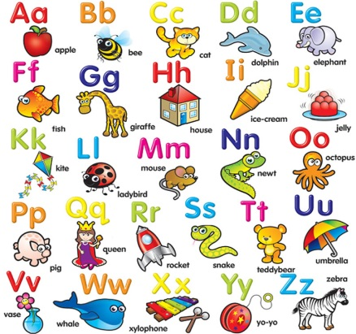
Middle  10 min  5 minutes  10 min  End | T: Children, are you tired? Do you want to relax? And now animals will help us to relax. It’s time to sing a song. Stand up, please! Sing and repeat the actions! Thanks! Take your seats!  5.Let’s start our lesson with the crossword. Look at the board. Here you can see 3 pictures. What are they?  - ученики разгадывают кроссворд устно вместе, выводится ключевое слово.  T: Well done! Let’s read the key word.  P: PET  T: What’s the Russian for “Pet”?  T: So the topic of our lesson is my pet. Today we’re going to read, listen and speak about pets.  Guessing game “Bingo”  Children are given pictures with sports. They listen to the teacher and raise the picture  Pupils sing a song according to the video  Clap, clap, clap your hands!  Clap your hands together!  Stamp, stamp, stamp your feet!  Stamp your feet together !  6.Look and match the pictures!  Ending the lesson.  Ask pupils to draw their favourite animals  Reflection:  - Was the lesson difficult for you?  - Did you get anything new and interesting for you?  - Did you have enough time for writing task?  - Did you like to work with cards and pictures?  The lesson is over goodbye! |  |  | Object sinroom cards  