ЖАҢАӨЗЕН МЕКТЕП-ГИМНАЗИЯСЫ

ҚР-ның Тәуелсіздігінің 25 жылдығына орай өткізілген
ашық сабақ

English
Listening and speaking “Flash Mobs”

Пән мұғалімі: Раметулла З.М.
11 «А» сынып
25.11.2016ж.

Жаңаөзен – 2016 ж.
Open Lessons theme: Listening and speaking “Flash Mobs”
The Aim: to introduce the term flash mob and the reasons of organizing it.
Speaking: Discussing any interesting points of the text, using and monitoring any difficult vocabulary as they discuss their ideas.
Vocabulary: witnessed world, congregated people, a rug, a passing fad, impromptu, gatherings, suppose, isolated, spirit of society, a truly international event, involved people, try to break it up, cause a disturbance, very peaceful, silent disco, referred to, realize.
Resources: Handout materials, grammar and vocabulary cards, listening text and a song
Methodology: Listening, speaking and answering the questions
The Procedure of the lesson
- ORGANIZATION MOMENT
Step 1 Communication activity “Go and find” Students go round the classroom to find extra information who and area practiced gerund and infinitive.
- can’t stand shopping
- enjoys learning English
- doesn’t mind standing in queues
- expects to pass all their subjects this year
- likes listening to the same music as you
- hates/likes dancing flash mobs
- depends on fashion accessories
- BACKGROUND INFORMATION
Background information is given as a homework research task and I ask them to tell the class what they found out.
Discussion task:
- What does Flash mob mean?
- Who is Bill Wasik?
- What is Harper`s Magazine about?
Flash mobs. The first flash mob was organized in Manhattan in 2003 by Bill Wasik, senior editor of Harper`s Magazine. They have since taken place all over the world. They are usually organized over internet or by sending text messages on mobile phones. Flash mobs started as a bit of fun, but have since been used to make political statements, with people appearing suddenly in large groups to make protests.
- LISTENING AND SPEAKING “FLASH MOBS”
Students look at the photos and share their ideas:
- What do you think is happening in each photo?
- What do you think they might have in common?

- “DATES and NUMBERS speak” An Interview with Ian Hicks
Students are given handout materials and they speak using them in their sentences.

- Listen and choose the correct answers
1. Why have flash mobs become more popular over the years?
a) Because it has become easier to pass on information about them.
b) Because more people know what they are.
c) Because young people have more free time.
2. What does Ian Hicks like most about flash mobs?
a) They bring people together.
b) They`re very entertaining.
c) They can be seen as works of art.
3. How many different cities took part in the great pillow fight of 2008?
a) About 25.
b) More than 25.
c) No one really knows.
4. Why did officials try to stop the silent disco at Victoria Station?
a) Because it was making too much noise.
b) Because they said it was causing a problem for travelers.
c) Because it was illegal.
5. Why does Ian choose the Macy`s Store flash mob as his favourite?
- Because it was the first.
- Because it was so imaginative
- Because it was so big
6. How many of his top three flash mobs has Ian Hicks taken part in?
- 0
- 1
- 2

- Singing a song “Accessory” by Jordan Taylor and write the verbs in the spaces.
- Dancing ‘Flash Mob’ with classmates.
- Assessment of and for learning
Written Reflections
"Minute Papers" or "Muddiest Points," these popular assessment techniques have students reflect immediately following a learning opportunity (e.g., at the end of a class or after completing an out-of-class activity) to answer one or two basic questions like:
- “What was the most important thing you learned today?”__________________________________
_________________________________________________________________________________
- “What was the most confusing topic today?”____________________________________________
_________________________________________________________________________________
-“What important question remains unanswered?”_________________________________________
_________________________________________________________________________________"Что было самым важным, что вы узнали сегодня?"
"Что было самым запутанной теме сегодня?"
"Какой важный вопрос остается без ответа?"
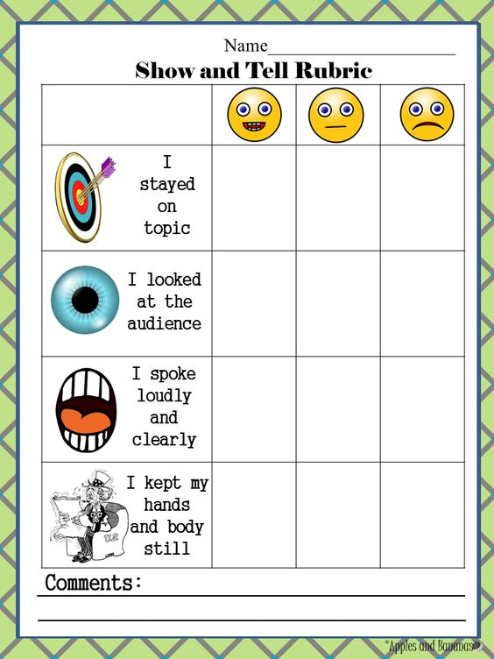

- Homework Extra reading “Fashion Model” p. 39
- Speaking “Fashion Model”
- Writing “Some advantages and disadvantages of fashion model”

