Module 3: Treasure and Heritage  5 LESSON:  Theme: Our planet Treasure |  | School: # 3, Talgar town
Date: 18.11.2019 |  | Teacher’s name: Adilbayeva M.A
CLASS: 4 G |  | Number present: | absent:
Learning objectives(s) that this lesson is contributing to | 4.1.4.1 understand an increasing range of short supported questions on general and some curricular topics;  4.2.5.1 pronounce an increasing range of words, short phrases and simple sentences intelligibly;  4.4.2.1 begin to use joined-up handwriting in a limited range of written work;
Lesson objectives | All learners will be able to: read the new words and texts, do some exercises like rue or false
 | Most learners will be able to: listen and read the new words and text, do the tasks in a group
 | Some learners will be able to: listen and read the new words and text, do the tasks in a group and do formative assessment.
Assessment criteria | to talk about natural features.
Language focus | Structures: articles (a/an,the).  Language in use: Everest is a mountain. Mr.Smiles is an explorer. He travels all over the world.
Target vocabulary | Our planet’s treasure 1: waterfall, rainforest, river, desert, ocean, island, lake, mountain.
Cross - curricular
links
ICT skills | Active Whiteboard, audio and presentation
Plan
Planned timings | Planned activities (replace the notes below with your planned activities) |  |  | Smiles Resources
Opening  4.1.4.1  4.2.5.1 | Class organization  Learning and lesson objectives are introduced.  Before beginning the lesson pupils will read a poem about nature.  The woods are lovely, dark and deep,  But I have promises to keep  And miles to go before I sleep,  And miles to go before I sleep.  Bell work Asking home task from previous lesson ex 17 p 43 PB  Doing exercise to revise articles a, an, the:  - I have got _____umbrella.  - ___Sophie is from ___Italy.  - Mr. Smith is ____teacher.  - ___New York is in the USA.  - Look at………Sun! It’s shining very brightly!  Children must write articles where it is necessary. |  |  | PPT
Middle  4.2.5.1  4.1.4.1  4.4.2.1  4.4.2.1 | PRESENTATION AND PRACTICE  (Activities to present and activate the new language.)  Presentation of the new words  Our Planet’s Treasure 1  Children listen to these words from audio then they repeat it. After repeating every pupil reads these words:  Lake –озеро  Mountain – гора  Waterfall – водопад  Ocean – океан  Rainforest – тропический лес  Desert – пустыня  Island – остров  River – река  ex15 Read and choose . Then say.  Explain the activity. Allow the pupils some time to complete it. Check their answers  Answer key  1 A 2 B 3 B 4 B 5 A 6 A  Then elicit answers from individual pupils.  e.g. Malta is an island ., The Pacific is an ocean . etc  STUDY SPOT  (Activities to present and practice the articles.)  Listening to a text: Listen and read.  Pupils are divided into two groups. They will listen to a text together. The first team reads two parts of the text, and the second team reads rest of the text.  WORLD RECORDS  Pupils listen to the text “World records” then they read id by chain.  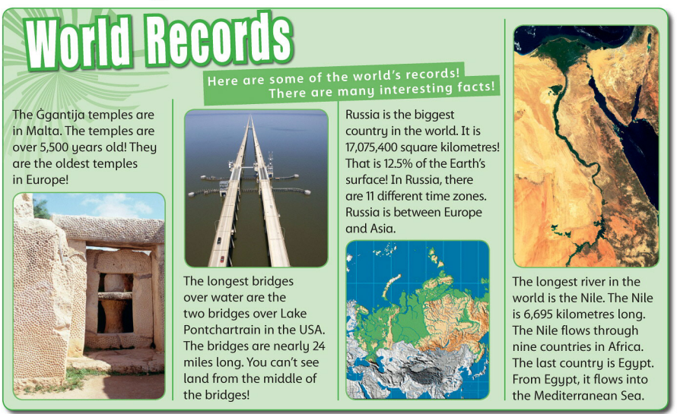  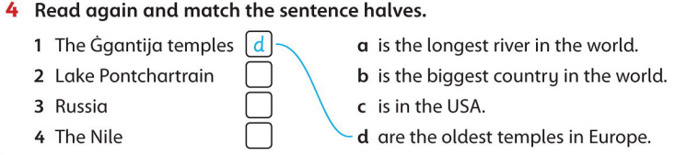  Rhombus  After reading the text pupils must write on stickers important statements, then they must make “rhombus”. At the top of rhombus the main statements must be hanged. At the end of rhombus the less statements must be hanged. |  |  | (Track 35 CD1)  CD 78 Family and Friend 3
End  4.4.2.1.  4.1.4.1 | (An activity to consolidate the language of the lesson)  Formative assessment tasks  - Look and count. Write numbers  - Write. Use the new words  - Read the text again and fill in the gaps.  Reflection (W):  Students will write:  - One question they still have  - Two things they have enjoyed or found interesting  - Three things they have learned today  Home task: Activity book p 29
Additional information
Differentiation – how do you plan to give more support? How do you plan to challenge the more able learners? | Assessment – how are you planning to check learners’ learning? | Cross-curricular links Health and safety check ICT links  Values links
Reflection  Were the lesson objectives/learning objectives realistic?  Did I stick to timings?  What changes did I make from my plan and why? | Use the space below to reflect on your lesson. Answer the most relevant questions from the box on the left about your lesson

