Unit of a long term plan 2 | School: Pavlovskaya secondary school
Date: 23.07.2017 | Teacher name: Shepel Artyom Andreyevich
CLASS: 5 | Number present: 7 | Absent: 0
Lesson title | Animals
Learning objectives(s) that this lesson is contributing to (link to the Subject programme) | 5.C4 evaluate and respond constructively to feedback from others;  5.UE9 use simple present and simple past regular and irregular forms to describe routines, habits and states on a limited range of familiar general and curricular topics;  5.R6 recognize the attitude or opinion of the writer in short texts on a limited range of general and curricular topics;  5.R4 read with some support a limited range of short fiction and non-fiction texts.
Lesson objectives | All pupils will be able to describe the animal by simple sentences;  Most pupils will be able to understand the text “Save the animals” and can answer the questions  Some pupils will be able to use present simple and discuss the problems concerning the animals from “Red book”, help others to understand the topic in groups.
Assessment criteria | Understand the general ideas of text “Save our animals”;  Describe animals using present simple;  Can find visual different between carnivorous and herbivorous animals and say about it using active form of present simple;
Values links | Animals’ protection;  Love to animals.
Cross-curricular links | Biology, Geography
Previous learning | Countable and uncountable nouns
Plan
Planned timings | Planned activities (replace the notes below with your planned activities) | Resources
Start  1-5 min. | Input strategy.  After greetings teacher shows the video and asks learners to guess what the lesson will be about.  Then discusses the aims and assessment criteria for the lesson.  Warm-up.  The animals live on different areas. Teacher gives learners sheets of paper with the words of song, and ask learners sing song together about animals’ homes. | “Mammals. Educational video for kids” https://youtu.be/hGonwMTPV6g  board  “Animals homesong” https://youtu.be/4Blw7Pg8xws
Middle  6-42 min. | Pre-reading  The teacher invites students to answer questions:  1.Is the blue whale endangered animal?  2.Are the birds mammal?  3.Are the bears endangered animals?  4.Are the snakes insect?  Reading  Class is divided into groups using the game  Read the text:  “Save our animals”  From year to year the interest to rare endangered animals grows up. Especially rare types of animals deserve great of attention and careful attitude.  Today the most well-known species of endangered animals, which are under the threat of complete disappearance, compute a blue whale, a Floridian panther, an arctic bear, a mountain gorilla, a tiger and a giant panda. Animals disappear as a result of people`s influence on the life. People involuntarily take away their small brothers` natural places of habitation, theirs fodder sites, cut down forests, cultivate deserts, contaminate seas and atmosphere. As a consequence animals are exterminated as fast as by means of a gun, poison, traps.  Post-reading  One learner from each group comes to the blackboard and choose one of the pictures and they must ask questions from other learners.  The Venn diagram  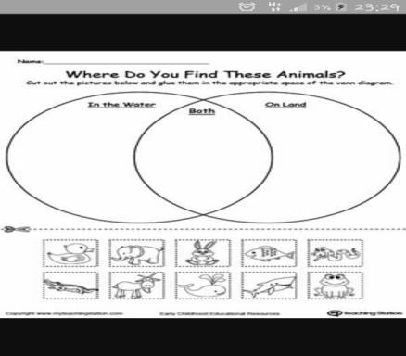  Peer assessment.  Watching video.  Teacher’s questioning differentiation (Bloom’s Taxonomy)  After watching the video, students try to describe the animal, which the teacher offers them using the present simple  After each group offers a description of the animal and its area.  TPR. “Running drawing”  Now the students in the group choose the artist. He will have to run out, read the word, then draw this animal. The rest guess the animal, and write down the first letter of its name. Collecting one letter will get the word.  Formative assessment with different task.  Change the tense I each of the following sentences. Use the tense given in brackets.  Descriptor  A learner: changes the tense in each of the sentences;  Uses the tense given in brackets correctly.  The high- motivated pupils must do 5-6 sentences.  The middle motivated learners must do 3-4 sentences.  The low motivated learners must do 1-2 sentences | Text  Board  https://youtu.be/FLLHsbe8HYM  Cards with name of animals
End  43-45 min. | Reflection . Ranking  Students are encouraged to rank with the help of ranking line what they have learned more or less from the proposed statements  - You can read the text with support  - You can recognize the attitude or opinion in the text  - You can use Present Simple and Past Simple  - You can give feedback to your partner  - You can use your knowledge from the lesson in practice  Summarizing | Stickers with ranking line
Additional information
Differentiation – how do you plan to give more support? How do you plan to challenge | Formative assessment – how are you planning to check learners’ learning? | Health and safety check
1)After watching video answering questions (33-35 min.)  2)Psychological differentiation (audial, visuals, kinesthetic) during the lesson;  3) different support during the lesson. | 1)Through observation;  2) peer assessment in groups. | 1)TPR (36-39 min.)  2) video (2:40 min)
Reflection  Were the lesson objectives\learning objectives realistic?  Did all the learners achieve the lesson objectives\learning objectives? If not, why?  Did my planned differentiation work well?  Did I stick to timings?  What changes did I make from my plan and why? | Use the space below to reflect on your lesson. Answer the most relevant questions from the box on the left about your lesson
Summary evaluation
What two things went really well (consider both teaching and learning)?
1

2

What two things would have improved the lesson (consider both teaching and learning)?
1

2

What have I learned from this lesson about the class or individuals that will inform my next lesson?

