Проверочная работа по теме «Present Continuous и Past Continuous»

Упражнение 1. Заполните пропуски глаголом в Present Continuous и Past Continuous, используя правильную форму глагола be.
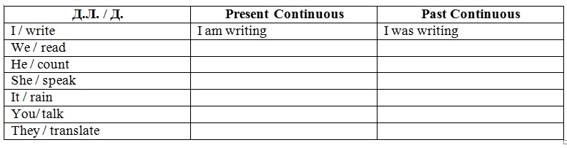Упражнение 2. Заполните пропуски глаголом в Past Continuous, используя правильную форму глагола be.
I ………… reading a book at 4 o’clock yesterday.
You ………. reading a book…
He ………. reading a book…
We ………. reading a book…
She ………. reading a book…
They ………. reading a book…
Упражнение 3. Перед вами вчерашний список дел Эмили. Напишите, когда и что она делала. Используйте словосочетания:
read; clean the room; have lunch; wash the dishes; watch TV
At 9 o’clock she was having breakfast.
At 9.30 she…
At 11 a.m…
At 1 p.m …
At 3 p.m …
At 5 p.m …
Упражнение 4. Заполните пропуски глаголом в Past Simple и Past Continuous, используя правильную форму глагола be.
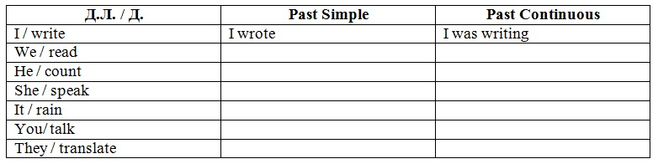
Упражнение 5. Заполните пропуски глаголом в Past Continuous и переведите предложения.
When I went out into the garden, the sun ______(to shine).
I __________(to eat) ice cream when you met me in the park yesterday.
When I came home, Tom ______ (to speak) over the phone.
Somebody got into the room when we ________(to sleep).
He saw Jane when she ______ (to cross) the street.
He ______(to wait) for Jenny when it started raining.
The woman ______(to have) a bath when she felt bad.
The man ______(to sit) by the window when he heard the noise.
We _______(to watch TV) when the door bell rang.
She______ (to read) when somebody knocked at the door.
They _____(to talk) about him when he suddenly came in.

Упражнение 6. Ответьте на вопрос, что делали члены семьи, когда приехала тетя Дженни.
ОБРАЗЕЦ. What were family doing yesterday when aunt Jenny came?
- John / listen to the radio ___________________________________
- his sister / have a bath ___________________________________
- the baby / play ___________________________________
- Father / read a book ___________________________________
- Mother / clean the room _____________________________________
- the cat / sleep ___________________________________
- grandparents / watch TV ____________________________________
Упражнение 7. Выберите правильный вариант.
- David (came / was coming) in when the children (wrote / were writing) a test.
- Mike (telephoned / was telephoning) me when I (took I was taking) a shower.
- Mike (spoke / was speaking) to me when his little sister (took / was taking) his book out of his schoolbag.
- We (met / were meeting) them when we (stood I were standing) at the bus stop.
- I (slept I was sleeping) when his mother (came / was coming) back.
- On Monday while he (cooked / was cooking) lunch the postman (brought/ was bringing) him a letter from his friend.
- When the teacher (came / was coming) into the classroom, the children (sat / were sitting) at their desks.

