ELECTRIC CIRCUIT

Ex. 1. Match a word with its definition:

Word | Definition
1) Circuit | A) A point of connection for closing an electric circuit
2) Loop | B) A safety device consisting of a strip of wire that melts and breaks an  electric circuit if the current exceeds a safe level
3) Series | C) An impedance or circuit that receives or develops the output of a  transistor or other device
4) Mend | D) Electrical circuits or components arranged so that the current passes through each successively
5) Fuse | E) A complete circuit for an electric current
6) Switch | F) To change or adapt the form, character, or function of; transform
7) Load | G) A device for making and breaking the connection in an electric cir- cuit
8) Source | H) A complete route which an electric current can flow around.
9) Parallel | I) A place, person, or thing from which something originates or can be  obtained
10) Convert | J) A thing made or adapted for a particular purpose, especially a piece  of mechanical or electronic equipment
11) Device | K) Repair (something that is broken or damaged)
12) Wire | L) Side by side and having the same distance continuously between  them
13) Terminal | M) Metal drawn out into the form of a thin flexible thread or rod

Ex.2 Read and translate the text.
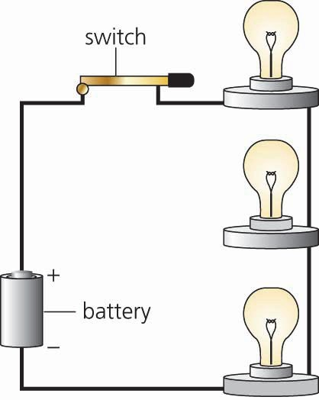
An electrical circuit is a closed loop formed by a power source, wires, a fuse, a load, and a switch. When the switch is turned on, the electrical circuit is complete and current flows from the negative terminal of the power source, through the wire to the load, to the positive terminal. Any device that consumes the ener- gy flowing through a circuit and converts that energy into work is called a load. A light bulb is one example of a load; it consumes the electricity from a circuit and converts it into work – heat and light.
Electric circuits can be drawn in diagrams using symbols. There are agreed ways of drawing these symbols so that circuit

diagrams can be read by lots of different people in order to make electrical devices or to mend them.
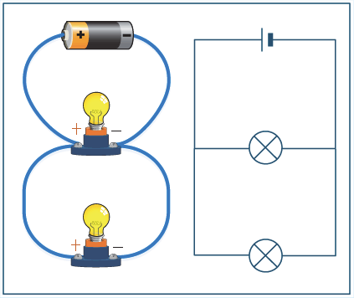
There are three types of circuits: series circuits, parallel circuits, and series-parallel circuits. A series circuit is the simplest because it has only one possible path that the electrical current may flow. If the electrical circuit is broken, none of the load devices will work. A par- allel circuit has more than one path, so if one of the paths is broken, the other paths will con- tinue to work.
A series-parallel circuit attaches some of the loads to a series circuit and others to parallel circuits. If the series circuit breaks, none of the loads will function. If one of the parallel circuits breaks, how- ever, that parallel circuit and the series circuit will stop working, but the other parallel circuits will continue to work.

Ex. 3. Answer the questions:
- What does an electrical circuit consist of?
- What is a load?
- Provide the examples of a load.
- What are the symbols of electrical circuit used for?
- How many types of electrical circuits are there?
- How do they differ? What will a trouble result in?

Ex. 4. Read the schemes (see Appendix 1).
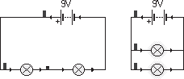
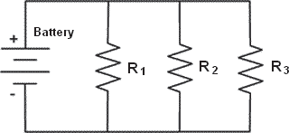

Mini-quiz to check your understanding
- Why do they call it a DC circuit?
- The electricity flows from the source around and back to the source in a circuit.
- Because most have a circuit breaker installed.
- To warn people of possible shocks.
- What happens when a light burns out in a series circuit?
- The other lights remain lit.
- The voltage increases dramatically.
- The circuit is broken and all lights go out.
- How could you turn off a parallel circuit?
- You can't turn off a parallel circuit.
- Put a switch before the parallel configuration, like near the battery.
- Unscrew one light bulb.

