Short plan
Long-term plan unit:  Unit 6. Explorers & Inventors |  | Gymnasium № 41
Date: 26.02-2.03 |  | Teacher name: Perzadaeva A.R.
Grades: 3 |  | Number present: | absent:
Theme of the lesson: Bright ideas

Learning objectives(s) that this lesson is contributing to |  | 3.L9 Recognise short basic words that are spelt out  3.UE6 Use demonstrative pronouns this, these, that, those in open and closed questions  3.UE7 Use personal object pronouns [indirect] in conjunction with direct object nouns to describe actions and events
Lesson objectives |  | Identify short simple words that are spelt out  Apply this, these, that, those in interrogative sentence  Describe actions and events using personal object pronouns with direct object nouns
Success criteria |  | - writes the words down correctly  - chooses the correct demonstrative pronoun to complete the sentence  - chooses the correct personal object pronoun  - replaces the underlined part with the correct personal object pronoun
ICT skills |  | no ICT
Previous learning |  | Marco Polo
Plan
Time | Planned activities |  |  | Resources
Beginning  3 min  5 min | Organizational moment  Teacher greets students; students respond to greeting and take their places.  Good afternoon? Glad to see you.  How are you?  What day is it today?  What date is it today?  What is the weather like today?  Teacher presents lesson objectives to students  Warming up  (I) Learners listen to the words spelt out by the teacher and write them down correctly.  1.  2.  3.  4.  5.  6.  7.  Teacher reads:  - nice  - useful  - silly  - dangerous  - clever  - easy  - difficult |  |  | worksheet for each learner
7 min | Start up activity:  (W) Teacher presents to students the demonstrative pronouns.  A demonstrative pronoun represents a thing or things:  - near in distance or time (this, these)  - far in distance or time (that, those)  near • far ⇒  singular ☺ this that  plural ☺☺☺ these those  Here are some examples with demonstrative pronouns, followed by an illustration:  - This is heavier than that.  - These are bigger than those.  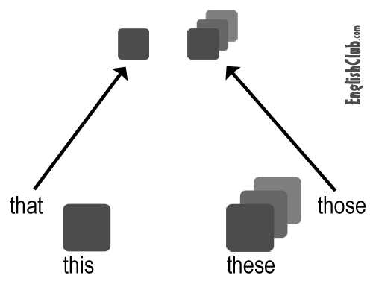  Subject Object  I me  you you  he him  she her  it it  we us  you you  they them  Object pronouns  We use object pronouns:  • as the object of the verb;  • after prepositions. |  |  | flashcards
Middle  21 min | (I)Task 1. Choose the correct demonstrative pronoun to complete the sentences.  - Is ______________ your invention? These This Those  - Look there! Is ______________the famous inventor on the bus? That This These  - Come here and look! Aren’t ______________robots nice? Those These That  - Are the computers in _______________room useful? These Those This  5.______________ your smart phone over there?  Is that Are that Is this  6.______________ electronic books your favourite?  Are these Those Are that  Key answers:  1.This; 2.That; 3.These; 4.This; 5.Is that; 6. Are these  (W)Energizer:  Stand up! Clap! Clap!  Arms up! Clap! Clap!  Step! Step! Arms down!  Clap! Clap! Please, sit down  (P)Task 2. Choose the correct pronoun to replace the underlined part.  1. The teacher gave the students the task to invent a robot for EXPO.  a. me b. them c. you  2. I am reading the book about bright ideas to my little sister.  a. her b. us c. him  - The boys are riding their bikes.  a. it b. them c. her  - My father is writing a letter to John about his new clever idea.  a. me b. her c. him  5. Sally is going to Anne. They will watch a film.  a. her b. him c. me  6. Can you tell the people about this car, please?  a. you b. them c. us  7. These electronic books are for Peter.  - him b. her c. you  8. Can you tell my sister and me about that plane, please?  a. her b. me c. us  Key answers:  1. b; 2. a; 3. b; 4. c; 5. a; 6. b; 7. a; 8. c |  |  | worksheet for each pair  worksheet for each learner
End  4 min | (I) Wrap-up.  Homework: learn the demonstrative and personal pronoun.  Feed back.  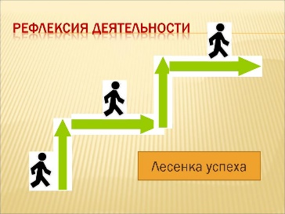 |  |  | card for reflection

