Short plan 20

Long-term plan unit:  Unit 3. Time |  | Gymnasium № 41
Date: 13.11-17.11 |  | Teacher name: Kazanzhidi O.F.
Grades: 3 A, B, V, G, D, E |  | Number present: | absent:
Theme of the lesson: Days of the week

Learning objectives(s) that this lesson is contributing to |  | 3.R1 recognise, identify and sound with support a limited range of familiar words in simple sentences  3.W4 write with support short basic sentences with appropriate spaces between words
Lesson objectives |  | All learners will be able to:  Identify the main idea of a short story on general and curricular topics  Most learners will be able to:  Give short, basic description  Some learners will be able to:  Understand short, narratives
Success criteria |  | - reads the text and writes the right day of the week under the picture according to the text;  - pronounces words of the week intelligibly;  - marks sentences for True and False information.
ICT skills |  | no ICT skills are focused on this lesson
Previous learning |  | Times of my day
Plan
Time | Planned activities |  |  | Resources
Beginning  1 min  5 min | Organizational moment  Teacher greets students; students respond to greeting and take their places.  Good afternoon? Glad to see you.  How are you?  What is the day today?  What the weather like today?  Warming up  (W) Game: «Telephone»  Student say the word in the ear to the first, the children transmit what they heard in a whisper along the chain, the last voice.
5 min | Start up activity:  (D) Teacher presents the days of the week using flashcards.  Than students arrange Days of the week from Sunday to Saturday.
Middle  27 min | (I) Pupils guess the crossword.  Across  1 DUTSEYA  6 AFDYIR  7 SAWNEEDYD  Down  2 UDYSNA  3 USAADYTR  4 OAMDNY  5 SHDYTURA  (W) Energizer:  Stand up! Clap! Clap!  Arms up! Clap! Clap!  Step! Step! Arms down!  Clap! Clap! Please, sit down  (I, f) Task 1. Read the text. Write the words of the days of the week under the picture. Say the words correctly.  This is Mike. He’s got small brown eyes. He can dance and he can swim. He can’t ride a bike.  Every Monday, he plays football with his brother at home. Every Tuesday, he swims with his friends at school. On Wednesdays, he sings Chinese songs. On Thursdays, he plays computer games at home. Every Friday, he draws pictures in his bedroom.  Task 2. Read the sentences. Write True or False next to the sentences.  1. Mike plays football with his sister. ___________________  2. He swims on Tuesdays. ___________________  3. Mike plays computer games on Thursday. __________________  4. Mike reads Chinese books. ___________________  5. He draws pictures on Wednesdays. ____________________  Descriptor:  A learner  • reads the text and writes the right day of the week under the picture according to the text;  • pronounces words of the week intelligibly;  • marks sentences for True and False information. |  |  | worksheets with crossword  worksheets
End  2 min | (I) Wrap-up.  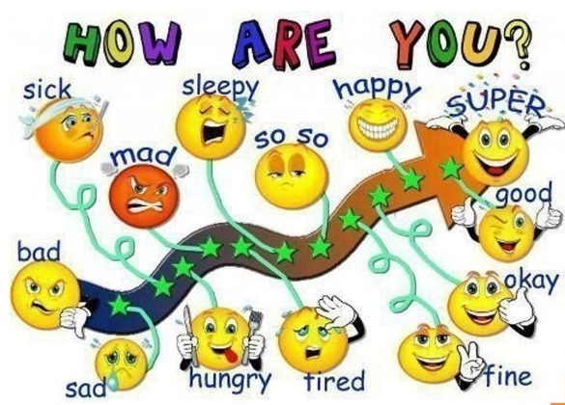 |  |  | Card for reflection

