Short plan № 123

Long-term plan: Unit 7. Reading for Pleasure |  | Gymnasium № 41
Date: 04.03-07.03 |  | Teacher’s name: Chirkova L.A.
Grade: 6 “A” |  | Present: | Absent:
Grade: 6 “B” |  | Present: | Absent:
Grade: 6 “V” |  | Present: | Absent:
Grade: 6 “D” |  | Present: | Absent:
Theme of the lesson: Macbeth
Learning objectives(s) that this lesson is contributing to | 6.4.7.1-recognise typical features at word, sentence and text level in a range of written genres;  6.4.8.1-use independently familiar paper and digital reference resources to check meaning and extend understanding;
Lesson objectives | ✓ To read for comprehension of general information  ✓ To comprehend the story using different resources to check meaning of words and phrases
Success criteria | - write active vocabulary  - read or listen the story and understand the main points of the story  - answer specific information questions  - use different resources to comprehend the story  - discuss the moral of the story
Value links | Respect, Support, Trust, academic honesty
Cross curricular links | Literature, History
Previous learning | Present and Past Simple, some topic vocabulary
Plan
Planned timings | Planned activities (replace the notes below with your planned activities) | Resources
5 min  7 min  10 min  10 min  5 min  5 min | Warm up ( W)  Teacher asks some questions to lead-in the topic.  • What Shakespeare books do you know?  • What is your favorite one?  Activity 1 (P, f) Pre-teaching vocabulary  Learners work in pairs or groups, try to find the meaning of active vocabulary. Then the teacher asks to read the new words and their meaning, Learners check up themselves.  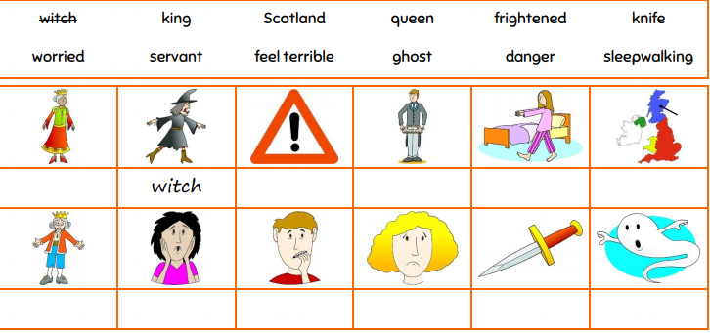  Students try to predict the content of the story looking and the words. What do you think the story is about?  Activity 2 (I, f) Reading general idea  Teacher asks learners to read the story “Macbeth” and order the events in the story. Students work in pairs. Check with the whole class.  Order the events of the story:  5 Macbeth feels terrible about killing Duncan and Banquo.  3 Lady Macbeth tells Macbeth to kill King Duncan.  1 Three witches tell Macbeth that he will be the new King of Scotland.  8 An army attacks the castle and kills Macbeth.  7 Lady Macbeth now understands that it is wrong to kill.  2 Lady Macbeth is very happy because she wants to be the queen.  6 The witches tell Macbeth that everything will be OK.  4 Macbeth tells his servant to kill Banquo.  Success criteria:  7-8 well done!  6-5 good result!  4-0 you can do it better!  Activity 3 (I, f,) Reading for specific information  Learners identify true and false sentences. They can read the text again if necessary.  Read the story and tick true or false T F  1. Three witches tell Macbeth that he will be the new King of Scotland.  2. Lady Macbeth knows if Macbeth is the king, she will be the queen.  3. Macbeth is happy frightened about killing King Duncan.  4. Macbeth thinks Banquo knows that he killed Duncan.  5. Macbeth is not happy being king.  6. Macbeth is excited worried people will know his secret.  7. Macbeth goes to see the army witches again.  8. Lady Macbeth is dancing sleepwalking because she feels terrible.  9. Macbeth sees the army and knows that the witches lied to him.  10. Macbeth is killed by the witches army.  Success criteria:  10-9 well done!  8-7 good result!  6-0 you can do it better!  Plenary:  Children think about or discuss the questions and decide if they think it was a good idea for Macbeth to listen to the witches and if they think it’s fair that the witches trick him. They share their ideas with the class.  Home task:  Use one of the previous graphic organizers(or find in the internet) and give the short summary of the story.  5. Reflection  Discuss with your partner:  - What three things have you learnt today?  - What questions do you have, based on today’s lesson?  - What skills have you used during this lesson? | Students’ answers  Sheet with task for each pair or group  Sheet with task for each pair  Worksheet with task for each group  Reflection questions on the board

