Hand-out
English language
Number of credits: 3 Academic year 2019-2020
Subject: Vocabulary Teacher: Zalgarayeva Gulzira Aydynbayevna
Level: Upper-Intermediate
Group: 10B2
Warming up
Vocabulary work

- Look at the stages of life. Which one are you in?
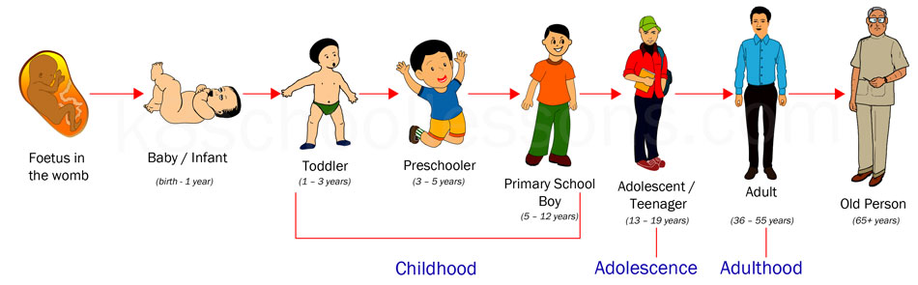
- In pairs match the activities to the stages of life above

-start a family; -crawl; -retire; go to school; -graduate; - learn to read and write;
-get a part-time job; -get married; -get a promotion; -get a job
A person normally starts a family in adulthood.

Exercise 1. Choose the correct word in the Student’s book exercise 1 on page 98.
- The village elder/native plans the day’s hunt
- He wants to get thrilled/close to the tribe.
- Some people find it difficult to keep/hang track of their time.
- He likes providing/sharing things with his friends.
- It seems that time has no supply/meaning to Onwas.
- Other tribes raise sheep and grow crops/animals.
- They never plan/invite for the future.
- I want to see the tribe in person/people.
- The man gathers/picks up his bow and sets off to hunt.
- The children don’t go to school and do as they please/feel.

Physical characteristics
Exercise 2. Complete the table. Use the following words:

hair lips age eyes face height nose complexion skin

- ___________ child, young man or woman, middle-aged, old, in his/her late/early twenties
- ___________ tanned, dark, pale
- ___________ tall, short, of average height
- ___________ skinny, plump, overweight, thin, slim, athletic, well-built
- ___________ oval, round, long
- ___________ full, thin
- ___________ brown, big, small, hazel
- ___________ big, flat, hooked

- ___________ curly, short, straight, long, wavy, bald, frizzy, fair, dark, shoulder-length
- special features wrinkles, freckles, glasses, beard, moustache

Exercise 3. Speaking. Use words from Exercise 2 to describe the people in the pictures:

Character
Exercise 4. Choose the correct adjective.
- Ulan behaves properly and sensibly. easygoing/arrogant/responsible
- Sultan doesn’t keep things clean and organized. forgetful/annoying/messy
- Dana feels uncomfortable with other people. ambitious/sensitive/shy
- Assel never lies. truthful/open-minded/bold
- Aizhan uses her common sense to solve problems. grumpy/sensible/self-confident
- Damir likes being with people. impatient/generous/social
- Askar always embarrasses people with what he says. carefree/rude/brave
- Zulfia thinks she is the best. arrogant/frank/honest
- Natalya takes pride in her looks. bossy/vain/stingy
- Kanat has very good manners. mean/polite/outgoing
- Yerasyl enjoys telling people what to do. helpful/bossy/noisy
- Max is always nervous or worried. anxious/noisy/sad

GRAMMAR COMMENT: WORD FORMATION (-ING/-ED PARTICIPLES )

- We use –ing adjectives to describe wthat smb/smth is like. He’s an interesting person. (What is helike?)
- We use –ed adjectives to describe feelings. He feels frightened. (How does he feel?)

- Jarkin gets easily annoyed/annoying.
- He’s confused/confusing about her behavior.
- She’s an amused/amusing person.
- Roza is very interesting/interested in Math.
- The news is shocking/shocked!
- He’s such a boring/bored person.

Exercise 7. Writing. Write an article describing your family members. Tell the class.
________________________________________________________________________________________________________________________________________________________________
________________________________________________________________________________________________________________________________________________________________________________________________________________________________________________________________________________________________________________________________________________________________________________________________________________________________________________________________________________________________________________________________________________________________________________________________________________________________________________________________________________________________________________________________________________________________________________________________________________________________

GLOSSARY
ENGLISH | KAZAKH | RUSSIAN
crawl[krɔːl] | еңбектеп жүру | ползать
get a promotion  [ɡet ə prəˈməʊʃn] | жарнама алу | получить повышение по службе
hazel[ˈheɪ.zəl] | қой көз | карий
hooked [hʊkt] | имектеу | крючковатый
wrinkle[ˈrɪŋkl̩] | әжім | морщины
freckles[ˈfrekl̩s] | сепкіл | веснушки
arrogant[ˈær.ə.ɡənt] | тәкаппар | высокомерный, надменный
grumpy [ˈɡrʌmpi] | ашуланшақ | сердитый, раздражительный
vain[veɪn] | атаққұмар | тщеславный
stingy[ˈstɪndʒi] | сараң | скупой

References
Main literature
Aspect for Kazakhstan, Grammar schools, 10th grade Student’s Book, Jenny Dooley, Bob Obee, Express Publishing
Addtional literature
Stuart Redman, “English vocabulary in use”, Cambridge University, Press, 2010
https://science.howstuffworks.com/international-space-station6.htm

