[**ai**]

..\Pictures\Sports\1104.wmfThe k**i**te went h**i**gher and h**i**gher in the br**i**ght blue sk**y**.

[**au**] 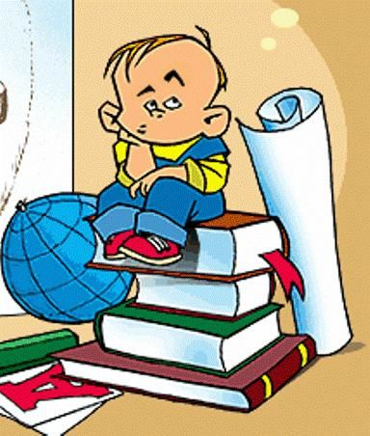

H**ow** would Br**ow**n work that

problem **ou**t?

[**b**]

Pictures\People\765.wmf**B**ar**b**ara is a **b**eautiful **b**lond with

**b**right **b**lue eyes.

[**ei**] 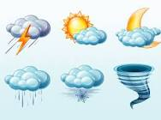

Rain, rain go to Spain!

Never come back again!

Pictures\People\1187.wmf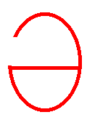[ **υ**]

D**o**n’t g**o** h**o**me al**o**ne. N**o**body kn**ow**s how l**o**nely the r**oa**d is.

[**f**] stuffer

**F**ine **f**ellows met at **f**ive on the **f**irst **F**riday of **F**ebruary.

[**h**]

Pictures\People\1039.wmf**H**enry **h**as a bad **h**abit of being be**h**ind time.

[**k**] 

I**ck**le-pi**ck**le, hu**ck**le-bu**ck**le,

Snu**ck**le in my shoe.

118Mi**ck**le-mu**ck**le,

Ni**ck**le-nu**ck**le,

Out go you!

[**n**]

** N**ed’s **n**umerous **n**eighbours are **n**ice perso**n**s.

[**o:**] 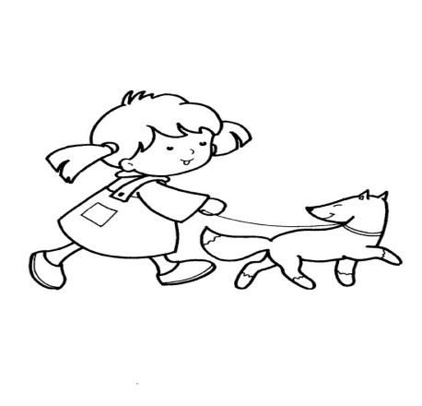

Y**our** d**au**ghter is

fond of w**a**lking

on w**ar**m

**au**tumn m**or**nings.

[**oυ**]

1196D**o**n’t p**o**ke your n**o**se into things you d**o**n’t kn**ow**.

[**s**] 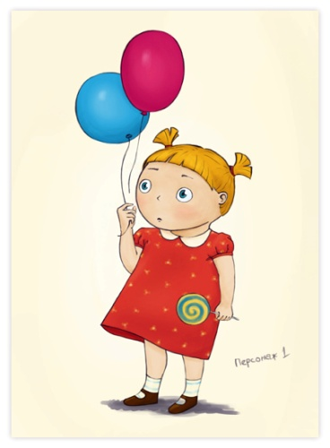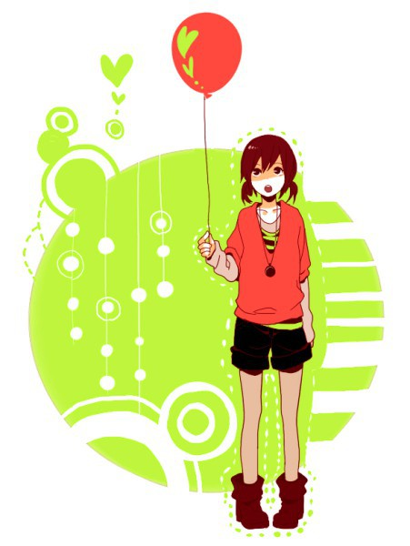

**S**ue is **s**ixteen thi**s s**ummer and **C**e**c**il as seventeen la**s**t **S**unday.

[**v**] 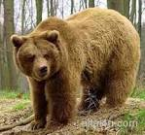

If you e**v**er e**v**er e**v**er meet a grizzly bear,

You should ne**v**er ne**v**er ne**v**er

ask him where

He is going.

For if you e**v**er e**v**er dare

to stop a grizzly bear,

You will ne**v**er meet another grizzly bear.

[**w**] 

**Wh**ether the **w**eather be fine

**Wh**ether the **w**eather be not

**Wh**ether the **w**eather be cold

**Wh**ether the **w**eather be hot.