Тема урока | Seasons and weather. English year.  Урок-закрепление
Цели урока | Fix up the theme «Seasons and weather. The English year».
Задачи | - Developing students’ knowledge on the topic.  - Developing critical thinking.  - Developing pair work, working in groups.
Лексика | Weather, seasons, months, holidays.
Результаты обучения | Students can work in pairs, can find useful information, revise and repeat words. Students can use information in life.
Источники, оснащение и оборудование: | Smart board, presentation, tasks on the sheets of paper.
Этапы урока | Деятельность учителя | Деятельность учащихся
Организационный момент | Greetings. How are you? What’s the weather like today? What ‘s the day today? What’s the date today? | Pupils greet tacher and answer to the questions. | 1
Определение  темы, цели и  задач урока | Let’s look at the board. What can you see? Let’s guess :what is the theme of our lesson today?  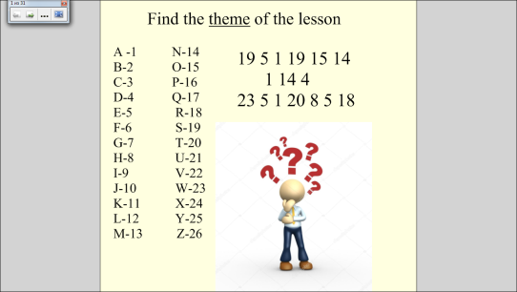  We’ll speak about seasons today. Do you know poems about seasons? Let’s match the poems with the pictures.  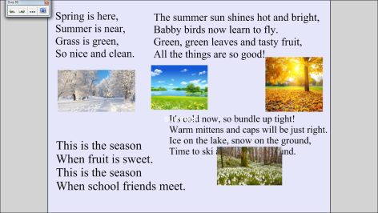  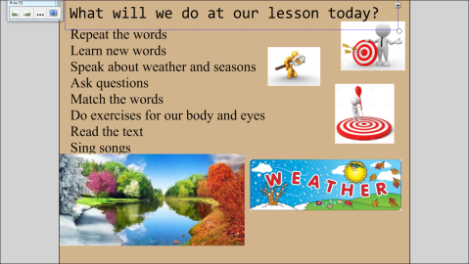 | Индивидуально-корпоративная работа (мозговой штурм). Children guess the topic and  Children match and read.  Pupils read the aims of the lesson. | 2  1  1
Актуализация знаний учащихся | So, let’s start our lesson. Let’s revise the sounds after me.  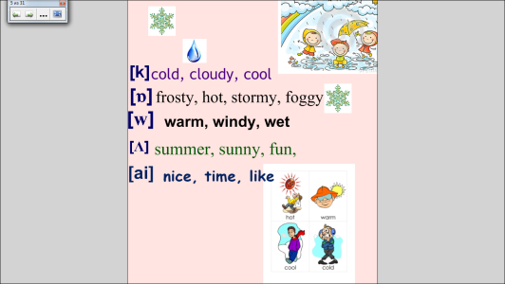  You ‘ve met some new words . I’d like to explain you the meaning of them  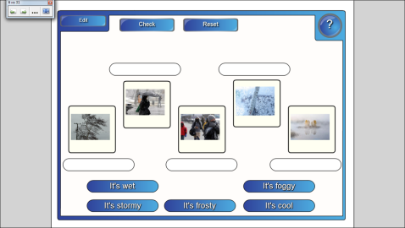  So, and what ‘s the weather like today? Is it winter? What’s the weather like in spring? Take the card number 1 and match the task.  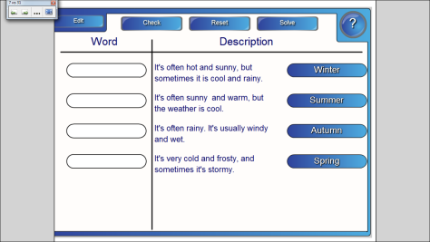  You know that every season has its months. Tell me, please, what winter months are in England?What summer months? Spring?  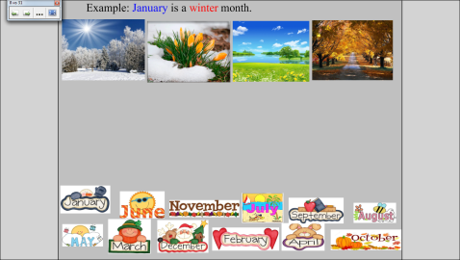  Let’s sing the song about “Months” | Pupils repeat after the teacher/ then read one by one.  Pupils listen very attentively and then do the task- they put the expression under the right picture and then check by pressing the butten.  Children work in pairs.  Pupils put the months to the right place according to the English year.  Pupils sing. | 2  2  1  2
Основная часть урока | What can you do in each of the season? What do you like to do in spring?In winter? Let’s revise. Put the activities to the season season. (Card 2)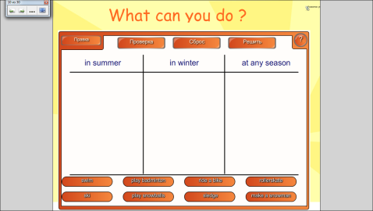  What season do you like? Why? What do you like to do in spring?Let;s make up sententences about seasons and then we’ll ask each other qestions.  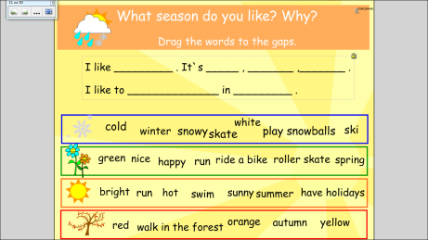  Activity time.  Don’t be lazy , dear friends.  Hands on shoulders, hands on neck,  Hands on stomach, hands on back,  Hands on hair, hands on chest  Are you tired? Let us rest.  Let’s do another exercise to have rest. I say the word on the topic season and weather- you clap your hands. It the word is not from the topic seasons and wearher- you sit down.  Friend,foggy, breakfast, orange, autumn, cool, head, pineapple, cold, windy, elbow, feet, sunny.  Thank you. Sit down.  Let’s ask each other about your favourite season. Let’s match questions to the answers.  Now, use the question and ask your partner.  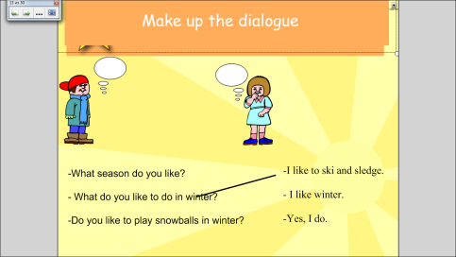  Children, do you like spring? What do you like to do in spring, Stas? What spring moths do you know in England?  Let’s read the text about English spring months.  Did you like the text?  What do you like in the text?  Let’s do the next exercise. You should read the sentence and tell : True or False.  Your eyes read, read, and read,and they are tired. Let’s do the exercises for your eyes.  Look left, right  Look up, look down  Look around.  Look at your nose  Look at that rose  Close your eyes  Open, wink and smile.  What season do we speak today about?  I’d like to prefer you to do another exercise. You change the text about winter into the text about spring.  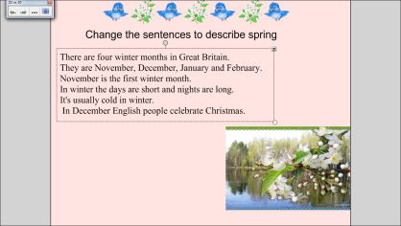  You did an excellent work. That’s right.  Before we finish our lesson . Let’s remember the words that we know about weather and seasons.  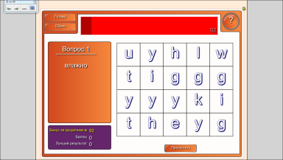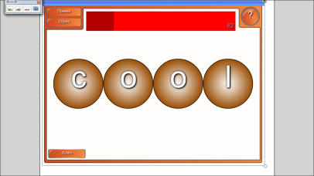  Are you happy?  Let’s sing the song.  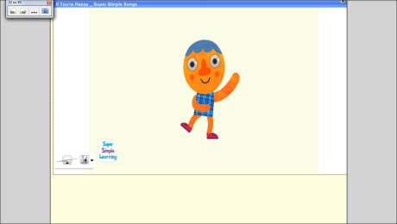 | Pupils work in pairs. Guess what they can do in each season. After finishing children come to the board and match expressions one by one.  Children make up the sentences.  Pupils do actions.  Children ask each other questions. Work in groups.( pupil from the first group comes at the board- the second group asks questions etc. )  Pupils read the text one by one and translate if it is necessary.  Children work in pairs. Then teacher asks one of the pupils and check.  Pupils do exercises for eyes.  Pupils work in pairs. Change the words in the text.  Then check together with the teacher.  Children guess the words that we learnt  at the lesson.  Children sing the song. | 2  2  3-4  6  77877  3  1  2  4  3
Домашнее задание | p. 91 ex. 9 to read the text and translate,  ex. 12,p. 93 prepare for dictation |  | 1
Итоги урока | 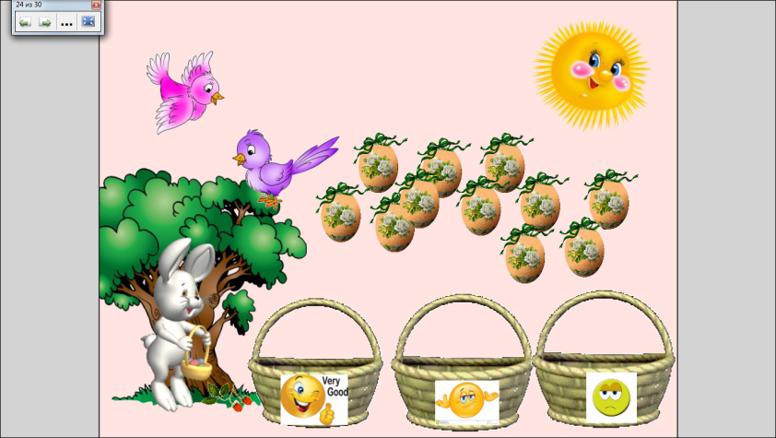  You were very active today.I’ll put you “5” for this lesson. The lesson is over. Good bye. | Высказывают своё мнение. | 1

