Отдел образования Ленинского района
Государственного учреждения образования “Гимназия №5г.Гродно”

ВНЕКЛАССНОЕ МЕРОПРИЯТИЕ
ПО АНГЛИЙСКОМУ ЯЗЫКУ
“HEALTHY HABITS”

ПОДГОТОВИЛИ: УЧИТЕЛЬ АНГЛИЙСКОГО ЯЗЫКА
I КАТЕГОРИИ КУДРАВЕЦ Ю.В.
УЧИТЕЛЬ АНГЛИЙСКОГО ЯЗЫКА
I КАТЕГОРИИ РУСНАК Н.А.

ГРОДНО 2012
Класс: 6
Продолжительность: 45 мин.
Цели:
- организовать деятельность учащихся по обобщению знаний учащихся, полученных в рамках текущей темы, изучаемой на уроках английского языка («Еда»)
- создать условия для развития внимания, памяти, мышления, речи, творческих способностей, интереса к общему делу
- обеспечить условия для развития умений работать в коллективе, принимать совместные решения
- обеспечить условия для воспитания положительных личностных качеств (ответственности, доброжелательности, чувства взаимопомощи)
- способствовать психологическому сплочению коллектива
- способствовать воспитанию бережного отношения к здоровью
- создать условия для расширения знаний учащихся о здоровом питании, навыков здорового образа жизни, отрицательного отношения к вредным привычкам

Оборудование: компьютерная презентация «Здоровое питание», мультимедийная установка, картинки по теме «Еда», карточки с заданиями, яблоко, грамоты
Подготовительный этап:
1.При выборе темы необходимо учитывать возраст учащихся, уровень владения английским языком, интересы и
способности учащихся.
2.Заранее предупредить ребят о мероприятии, оговорить условия проведения.
3. Подготовить презентацию с необходимым наглядным материалом, раздаточный материал, грамоты, снять
видеосюжет.
4.Оформить кабинет.

№ | Этап занятия | Время | Содержание деятельности | Примечание
 | Приветствие | 2 мин. | Good afternoon, dear boys and girls! Welcome our guests! We are glad to see you. Today we are going to travel by plane to “Healthy City.” Do you like travelling?  We start our trip from Gymnasium 5 and we are going to visit different towns such as Shoptown, Tastytown, Childrentown, Fattown, Healthycity. Come here and buy your tickets(вытягиваютсамолетики). So take your seats according to your tickets. We have two teams. | Организация мероприятия  Слайд 1  Слайд 2  Учащиеся вытягивают из коробки самолетики разных цветов и таким образом делятся на 2 команды. Ученики рассаживаются в соответствии со своим цветом (приложение 1)
2. | Ход мероприятия. | 4 мин. | Пилот: Good afternoon, ladies and gentlemen! This is your captain speaking. I’d like to welcome you abroad Belarusian Airways flight from Gymnasium 5 to “Healthy City.” Our flight will last 45 minutes. We are ready to take off. Please, fasten your seat belts. I wish you a very pleasant flight.  T: To make the flight more interesting let’s sing our pilot’s favourite song ”I like to eat apples and bananas ”. | Слайд 3  Для озвучивания пилота используется сайт: www.viki.com  Слайд 4  (приложение 2)
3. | Конкурс 1 | 3мин. | T: While we were flying and singing our reserves came to an end. So we have to lend. Our first stop is “Shoptown”. Do you like shopping? What do you like buying in the supermarket? Have you ever gone shopping for food? Who goes shopping for food in your family? So now you have a chance to go shopping yourselves. | Слайд 5  Учащиеся выбирают по одному члену команды для участия в конкурсе «Бег с тележками»  Для этого конкурса использовался сайт: www.britishcouncil.org
4. | Конкурс 2 | 3мин. | T: After visiting the supermarket we ask you to take your seats. We continue our trip. As you see the next stop is “Tastytown”. Look at your cards. We have bought a lot of food and now you have to divide these products into 4 groups: give energy and have fibre, have vitamins and minerals, have calcium and protein, not good for you. | Слайд 6,7  В следующем конкурседолжны распределить продукты по 4 группам  (приложение 3)
5. | Конкурс 3 | 2 мин. | T: We continue our flight. The captain has some interesting information for you. How much food do you think you will have eaten by the time you are 75? How much chicken will you have eaten? How many eggs? How much juice? What are your ideas? So look at the screen and listen attentively. | Слайд 8  слайд восьмой знакомит учащихся с познавательной информацией. В роли гида выступает пилот ;используется сайт: www.viki.com
6. | Конкурс 4 | 5мин.  2 мин.  6мин. | T:We flew to the next town. It’s “Childrentown”. In this city we will visit a famous place ”The Food Pyramid”.  This pyramid helps children to be healthy and strong. It shows them what they need to eat. Look. What’s happened? The pyramid is destroyed. I think children need our help. Would you like to help them to build the pyramid? They will tell you about this pyramid. Look at them and listen attentively.  T:Look at your desks. You have bricks from this pyramid. Think 1 minute where you will put them. Go to the blackboard and build.  T: You see the pyramid diet is very simple. Different kinds of food are at different levels of the pyramid. You see the bottom of the pyramid is the biggest part. It has bread, pasta, potatoes… They give us energy to work and play. About 50% of your diet should be these products. At the second level are fruit and vegetables, such as …. They have a lot of vitamins, minerals. They help our eyes, skin and teeth. These should be about 30% of your diet. Above fruit and vegetables are protein-rich food like meat, fish, beans and milk group: cheese, yoghurt …They give us calcium. They are good for our teeth and bones. This food should be about 18% of your diet. The top of the pyramid is the smallest part. It has food you should eat only sometimes because they are fat, sugar.  T: Now children can eat healthy food. But there is one more hero in this town. He is eating everything and the others animals and children are angry. How can they stop the hippo? What do you think? Look how they can stop the hippo eating all their food. After listening you’ll have some tasks from the children. | Слайд 9,10  Для того чтобы восстановить пищевую пирамиду учащиеся слушают видео запись, подготовленную учениками другого класса.  Учащиеся имеют на партах «кирпичики» с названиями продуктов.  Используя их обе команды восстанавливают пирамиду.(Пирамида нарисована на доске и разделена на половину для каждой команды)  (Приложение 4)  Анализ пищевой пирамиды.  Слайд 11  Учащиеся смотрят видео, а затем выполняют задания  (Приложение 5)
7. |  | 2 мин. | T: The pyramid is restored, the hippo left the town. The children have a festival. They invite you to their festival. Let’s dance together their favourite dance. | Слайд 12  Учащиеся танцуют.
8. | Конкурс5 | 6 мин. | T: The next stop is “Fattown”. Look at the people. Do you like them? What do they eat? What does he eat? Let’s give him some advice about healthy eating habits. You must make up sentences and you’ll get the advice about the healthy eating.  Put your advice into my envelope. We’ll send it to him. Maybe he’ll red the advice and think about his unhealthy life. | Слайд 13  Учащиеся смотрят слайд и высказывают свое отношение к очень полным людям к образу их питания.  Они составляют советы по правильному питанию и вкладывают в конверт .Используется глагол should / shouldn’t  (приложение 6)
9. | Конкурс 6 | 3мин. | T: At last we have landed in “Healthycity”. You have  already known a lot about healthy eating, you can even give  advice. Let’s pass the test about balanced diet. | Слайд 14  Учащиеся выполняют тест «Здоровое питание»  и соревнуются, кто лучше усвоил материал.  Для этого конкурса использовался сайт: www.britishcouncil.org
10. | Подведение итогов и награждение. | 3мин.  3мин. | T: Our flight came to the end. Let’s count your points. The winner is… But we give … to everyone. We hope you knew a lot useful information about our health.  T: We would like to finish our trip. This is a magic apple. The apple is a symbol of health. Pass it to your friends with good word to him/her. ”I wish you to be healthy”. | Учащиеся награждаются  сертификатами «Удачного полета»  (приложение 7)  Как заключение они передают друг другу яблоко и желают крепкого здоровья.

Приложение 1

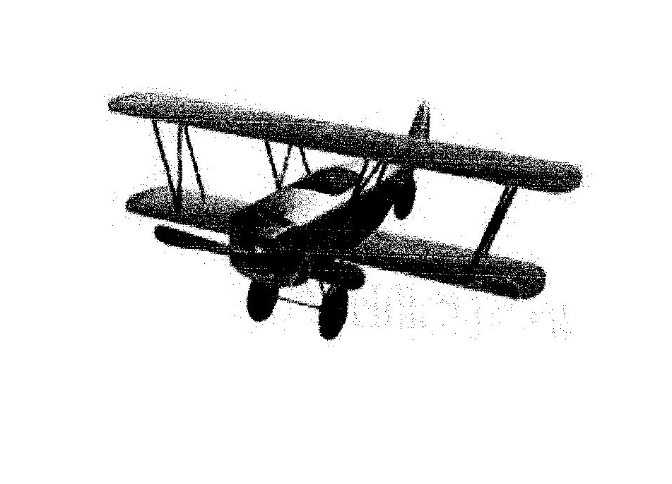

Приложение2
I like to eat, eat, eat apples and bananas
I like to eat, eat, eat apples and bananas
Now change the vowel sound to A:
I like to ate, ate, ate ay-ples and ba-nay-nays
I like to ate, ate, ate ay-ples and ba-nay-nays
Now change the vowel sound to E:
I like to eat, eat, eatee-ples and bee-nee-nees
I like to eat, eat, eatee-ples and bee-nee-nees
Now change the vowel sound to I:
I like to ite, ite, itei-ples and bi-ni-nis
I like to ite, ite, itei-ples and bi-ni-nis
Now change the vowel sound to O:
like to ote, ote, ote oh-ples and bo-no-nos
I like to ote, ote, ote oh-ples and bo-no-nos.

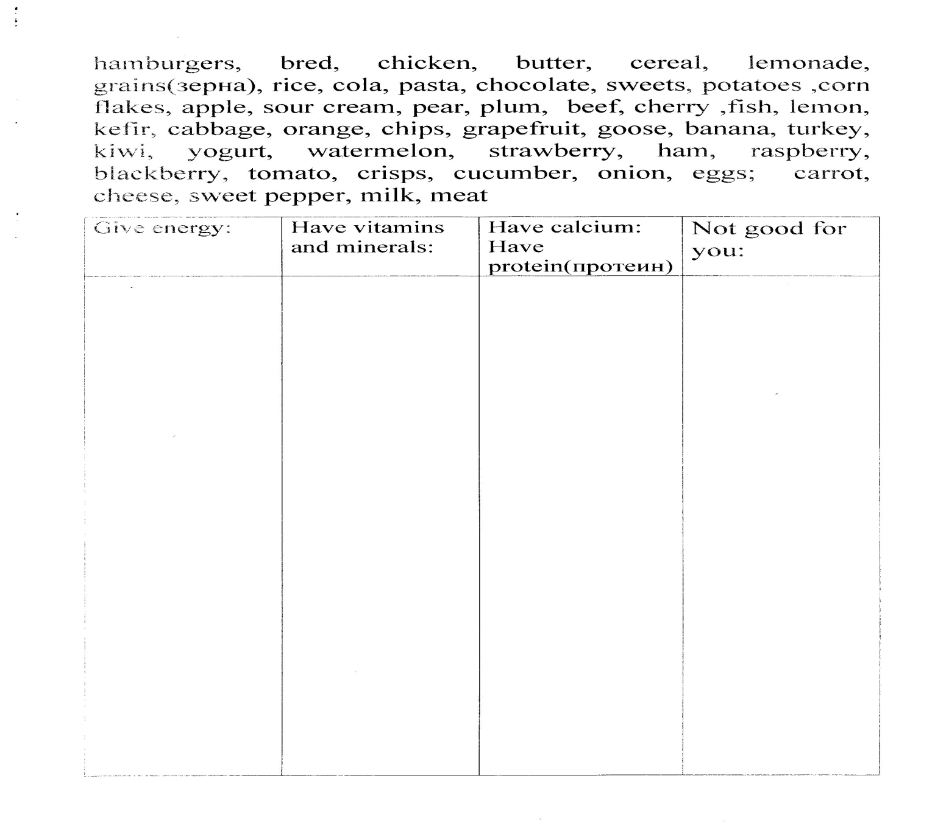
Приложение 3

Приложение4

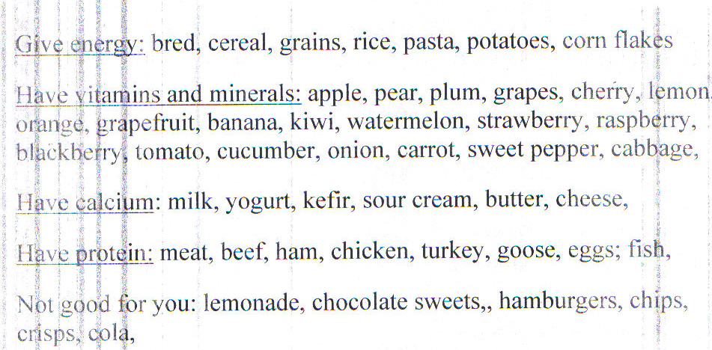

Приложение 5

The Greedy Hippo
There was a greedy hippo. He ate everything in sight.
From cheese to peas, chips and cake, he always had a bite.
Now Hippo he was selfish. He ate everybody’s food.
He ate the cat’s, the dog’s, the cow’s. He was very, very rude.
One morning after breakfast, he jumped into the lake.
One big splash and he was stuck. That was a big mistake.
The hippo he sank deeper, then began to shout.
“Help, please help, I’m sinking. Won’t someone pull me out?”
The animals all pulled and pulled, as hard as they were able.
Out he popped, ran past them all, and ate everything on their table.

The animals were angry, and thought they’d play a trick.
They made a pie from fish and soap to make old Hippo sick.
“Here you are, we’ve made a pie, especially for you.”
“Thanks,” he said, “I’ll eat it now. I’ve nothing else to do.”
First a nibble, then a bite, then a great big swallow.
He then went back into the lake, the place he loved to wallow.
But something wasn’t right, thought Hippo, “I feel quite odd inside.”
Now he had a tummy ache as the cooks looked on with pride.
Hippo learnt his lesson. It was the end of all their troubles.
He was last seen leaving town, blowing fishy bubbles.
You can read this story on the LearnEnglish Kids website:
http://learnenglishkids.britishcouncil.org/short-stories/the-greedy-hippo

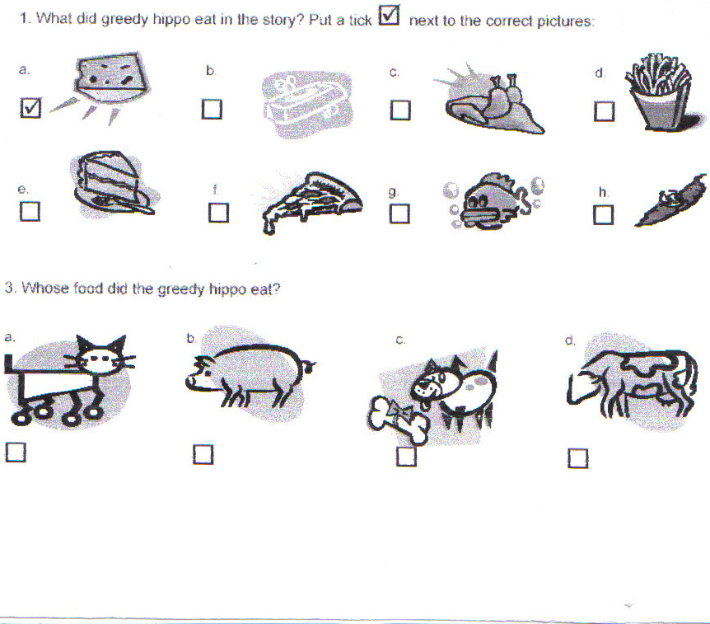

Приложение6

Advice
- You should eat a little salt, sugar and fat products.
- You should eat more fruit and vegetables.
- You should eat regularly because your body needs energy.
- You should drink 5 or 6 glasses of water per day.
- You should eat different kinds of food to stay healthy.
- You shouldn’t eat a lot of high-fat food.
- You should do a lot of exercises.
- You shouldn’t eat fast food.
- Enjoy your food.

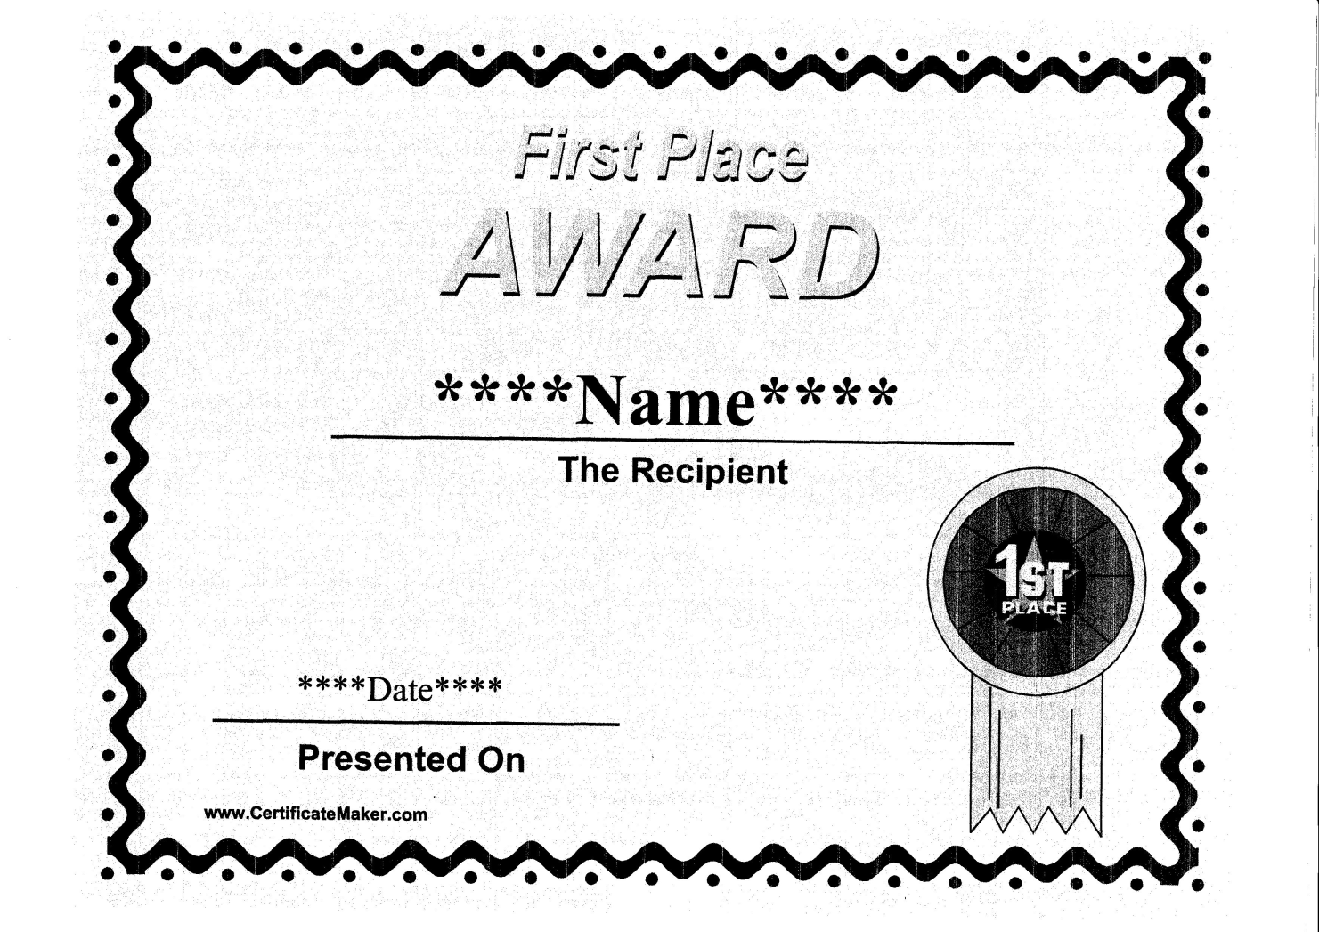
Приложение7

