С.Сейфуллин атындағы мектебі

“WELCOME TO LONDON!”

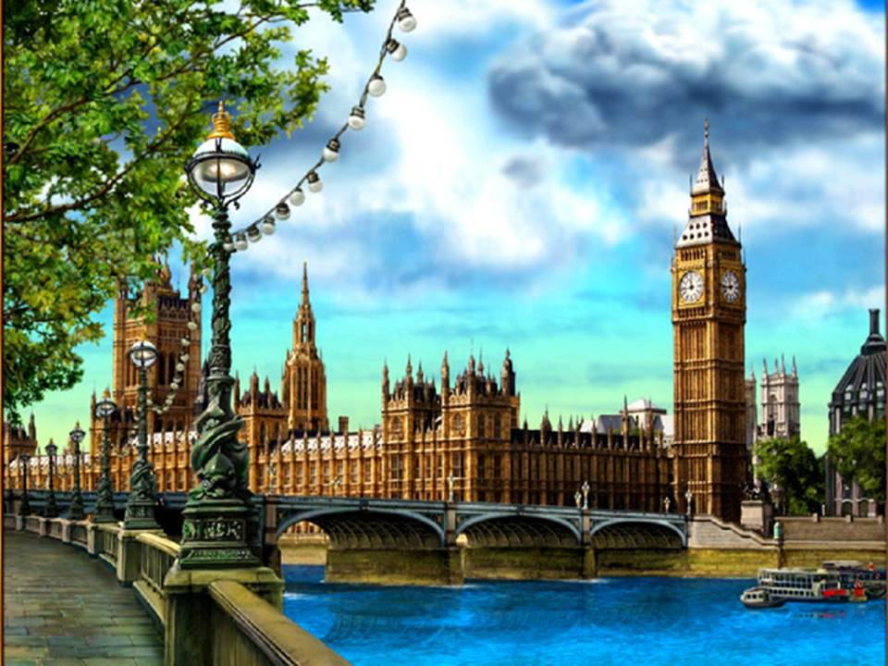

Дайындаған
Ағылшын тілінің мұғалімі
Турдалиева Санагул

2016

“WELCOME TO LONDON!”
Цели:
- Развитие коммуникативных навыков учащихся.
- Развитие творческих и креативных способностей.
- Активизация изученных лексических единиц.
- Пополнение словарного запаса.
- Развитие социокультурных навыков.
Задачи:
- Развивать лексические навыки.
- Развивать навыки аудирования и говорения (коммуникативных универсальных учебных действий).
- Познакомить с достопримечательностями Лондона (развивать социокультурную осведомленность).
- Развивать творческие способности учащихся в исполнении песен и стихотворений из детского фольклора на английском языке.
- Развивать навыки компьютерной компетенции в создании презентаций.

Ход мероприятия
Teacher:
- Hello, my dear friends! I am glad to see you. Today we’ll travel to England and know more about London. Seven royal ravens and Russian girl Ann will help me.
Slide 1.”Welcome to London!”
Cedric: Hello, dear friends! I’m the royal raven. I’m Cedric. I’ve got a friend. Her name is Ann. She is from Russia, from Moscow. She is a very nice girl. Yesterday evening she arrived to London and stayed with her family in the house of Martin and Diana Dillon. And now I’m waiting for her. I’m going to show her the capital of Great Britain- London.
Ann: Hello, Cedric? How are you?
Cedric: Hi, Ann! I’m very well! And you, my dear friend?
Ann: Oh, I’m OK, thank you!
Cedric: Are you ready to visit London?
Ann: Yes, I’m, Cedric!
Cedric: Let’s start! Come on!
Slide 2. “Buckingham Palace”
Ann: Ah, what a nice palace, Cedric! What is its name?
Cedric: It’s Buckingham Palace. The home of the Queen. Buckingham Palace has served as the official London residence of Britain's sovereigns since 1837.
Slide 3. “Queen Elizabeth II”
Ann: Is it really kings and queens are still living in England?
Cedric: Yes, it is. It’s true. Queen Elizabeth II lives in this palace with her family.
Slide 4. “Pussy-Cat and Little Mouse”
Ann: Cedric, look, who is it?
Cedric: It’s Pussy-cat with Little Mouse.
Two girls in costumes of the cat and the mouse recite the rhyme “Pussy-cat”.
Slide 5. “The Three little Kittens”.
After that three children in costumes of the kittens and Mother Pussy-Cat sing the song “Pussy-cat and the Three little Kittens”.
slide 6. “Trafalgar Square”.
Cedric: Meet, Ann. This is my friend Munin.
Ann: Hello, Munin! What is this square?
Munin: This is Trafalgar Square, Ann. You can see a lot of tourists and guests there. It’s the centre of London. Trafalgar Square was built to commemorate
Admiral Nelson on his victory in the Battle of Trafalgar. The square is the site of Nelson's Column which has four giant lions at its base.
slide 7.”Scots with Bagpipes”.
Ann: Look, Munin! Who are those men dressed in kilts with bagpipes in their hands? Do they live in London too?
Munin: Would you like to know about the Scots? Scottish people live on the North of The United Kingdom. They wear kilts and play their national musical instruments- bagpipes. Let’s listen to their unusual music.
slide 8. video with Bagpipes
slide 9. “Ba, ba, Black Sheep”.
Ann: Munin, how lovely are these sheep!
Munin: Kids in Great Britain like them very much and sing the song about them. Look, Ann, they can sing and dance.
Three children in costumes of sheep sing the song “Ba, ba, Black Sheep” and dance to music on slide №9.
slide 10. “Tower Bridge”.
Thor: Hello! My name is Thor.
Ann: Nice to meet you! I’m Ann.
Thor: Cedric asked me to tell you about the Tower Bridge. The Tower Bridge has stood over the River Thames in London since 1894. At the Tower Bridge Exhibition you can enjoy views from the high-level Walkways and learn about the history of the Bridge and how it was built.
slide 11. video “London Bridge is Falling Down”.
Two boys sing the song “London Bridge is Falling Down”.
slide 12. “The London Eye”.
Hugine: Hello! My name is Hugine.
Ann: Hello! Nice to meet you! I’m Ann.
Hugine: I’m here to show you our London Eye. The London Eye was designed to celebrate the Millenium year 2000. It is a giant observation wheel located in the Jubilee Gardens on the South Bank. You can see up to 25 miles in each direction with views over some of the world's most famous sights, including St Paul's, the Palace of Westminster and Windsor Castle.
slide 13. “Westminster Abbey”.
Odin: Hello! My name is Odin.
Ann: Hello! Nice to meet you! I’m Ann.
Odin: Would you like to know about Westminster Abbey?
Ann: Yes, Odin. It’s so beautiful!
Odin: Westminster Abbey is a Gothic monastery church in London that is the traditional place of coronation and burial for English monarchs.
slide 14. “Tower of London”.
Guyllum: Hello! My name is Guyllum.
Ann: Hello! Nice to meet you! I’m Ann.
Guyllum: My dear friends, let me show to Ann our home – Tower of London.
Ann: My dear ravens, when I was at home in Moscow I heard the legend: once upon a time many years ago you settled in Tower to save London against the enemies of England . They say, if you fly away from the Tower London-city and the Great Britain will die? Is it true?
Guyllum: It’s true, Ann. It is the oldest building in Great Britain. Now the Tower is the historical site and museum. The Tower of London was founded by King William the Conqueror in 11th Century and has served as a royal palace and fortress, prison and place of execution, menagerie and jewel house. Seven ravens are living here now.
Ann: Oh, it seemed to rain!
Four girls sing the song “Rain, rain, go away” and dance with their umbrellas.
slide 16. “Big Ben”.
Hardey: Hello! My name is Hardey.
Ann: Hello! Nice to meet you! I’m Ann.
Hardey: Nice to meet you, too! Now we are standing in front of Big Ben. The name "Big Ben" is generally known to describe the clock tower as a whole. However, "Big Ben" is actually the principal bell within the tower.
Ann: Big Ben is a symbol of London, it is majestic as Eiffel Tower in Paris the Spasskaya Tower in Moscow. (Clock strikes)
Hardey, look over there! A little mouse is running up and down!
slide 17. video “Hickory-dickory-dock”.
A little girl in costume of mouse sings the song “Hickory-dickory-dock”.
Cedric: Look at the clock. What’s the time? It’s about 5 o’clock. We have to come back home and drink tea with milk. Hurry up, Ann! Go by bus with these kids. Bye-bye, Ann!
Ann: Thank you very much, my friends- ravens! Good-bye!
Ravens: See you soon!
slide 18. song “Wheels on the bus”.
All children stand in row and sing the song “Wheels on the bus” to the music.
slide 19. English Tea-Party.
Two children demonstrate their presentations.
slides 20-24 Presentations of recipes.
slide 25. “Enjoy your meal!”.
Teacher: Dear friends, I hope you liked the travel to London. Let’s taste these dishes prepared by our girls for the English tea-time. Bon appetit! Enjoy your meal!

